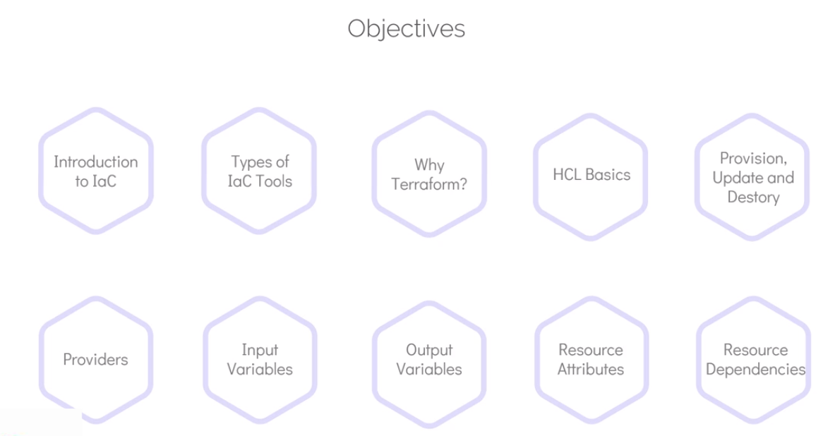

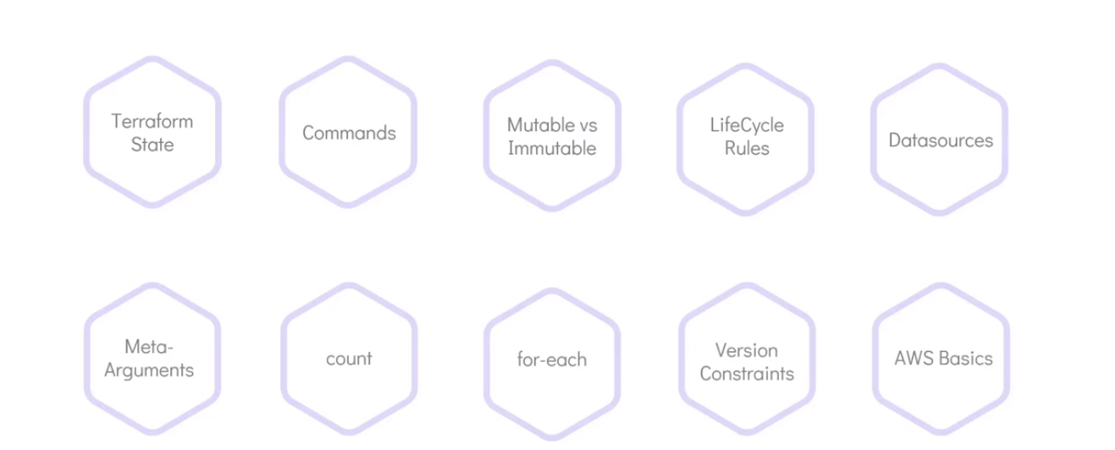

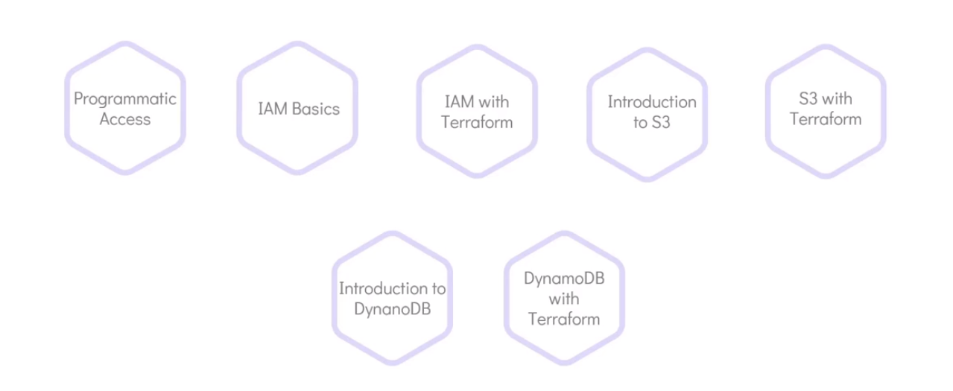

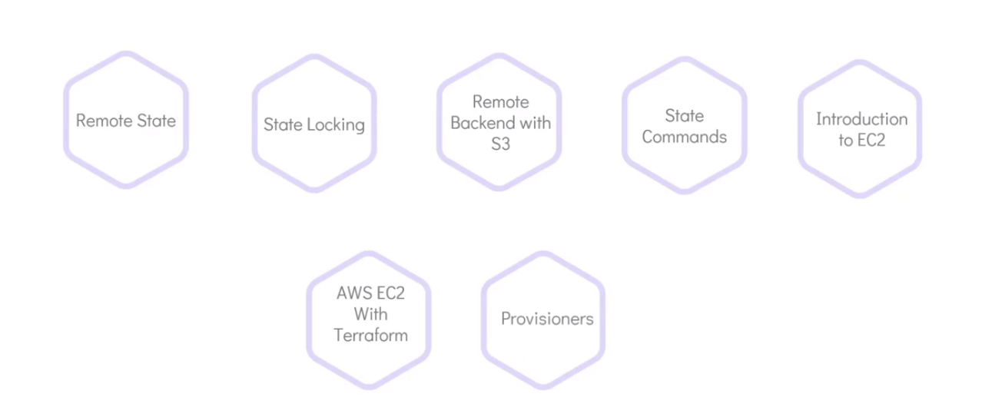

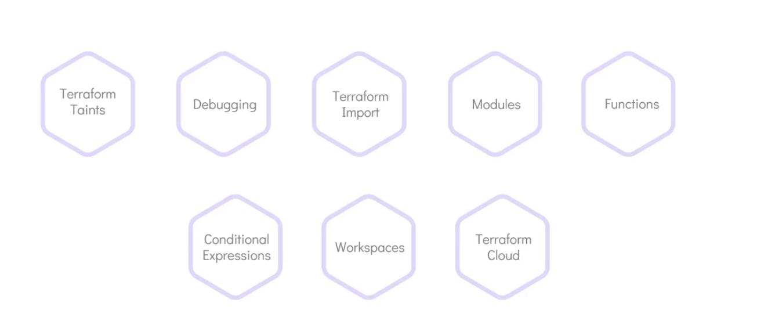

IOC:

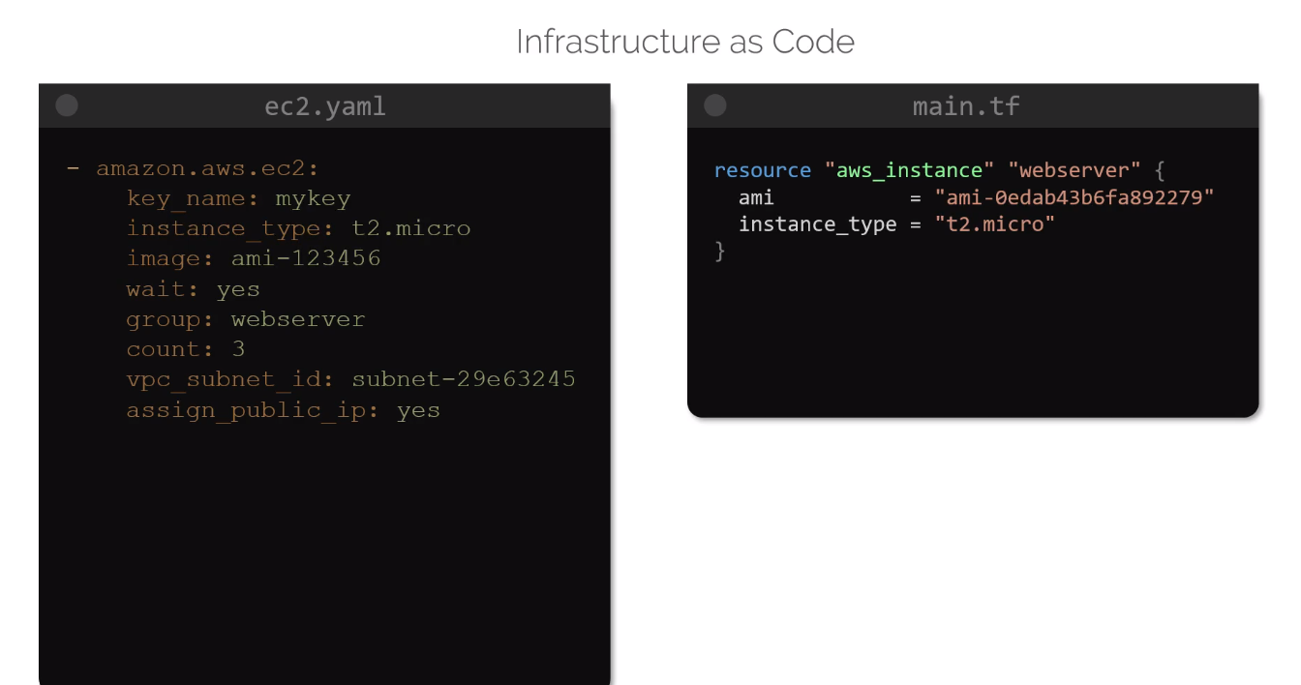

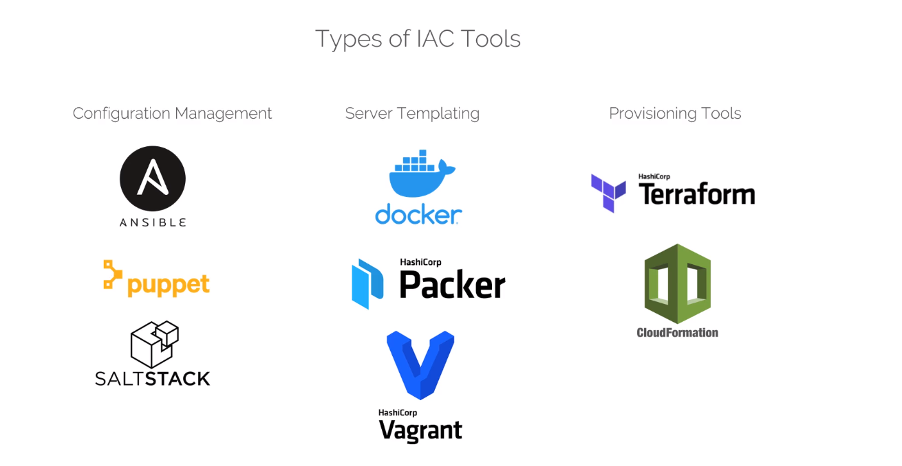

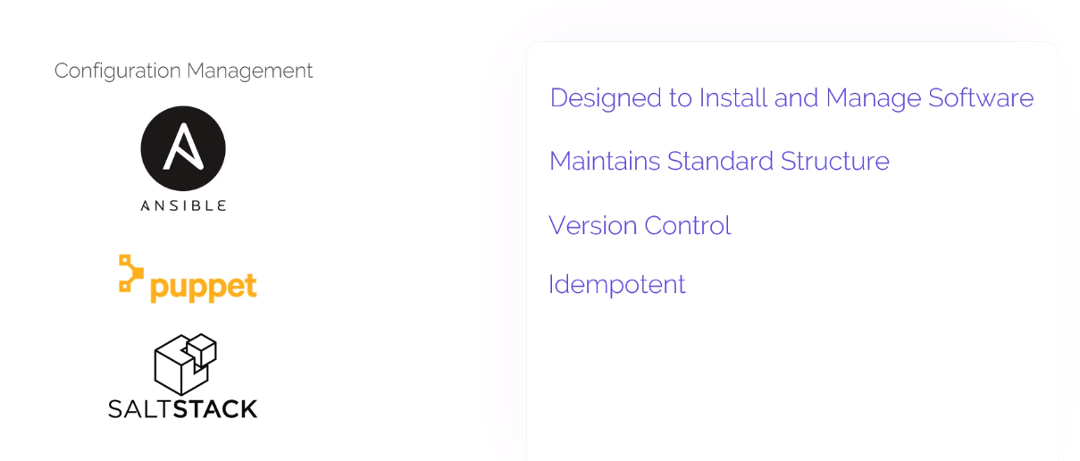

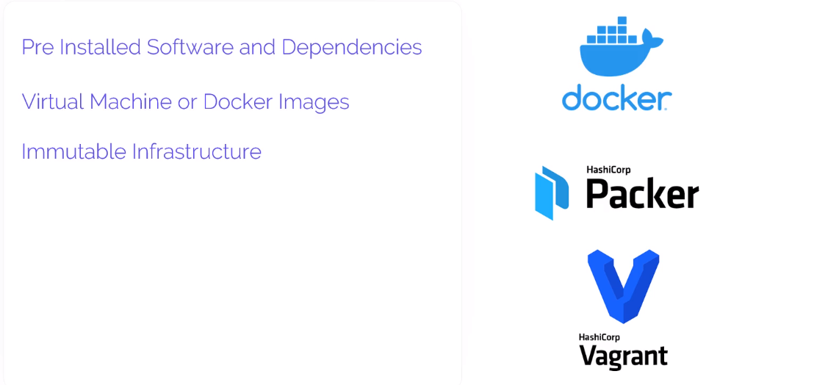

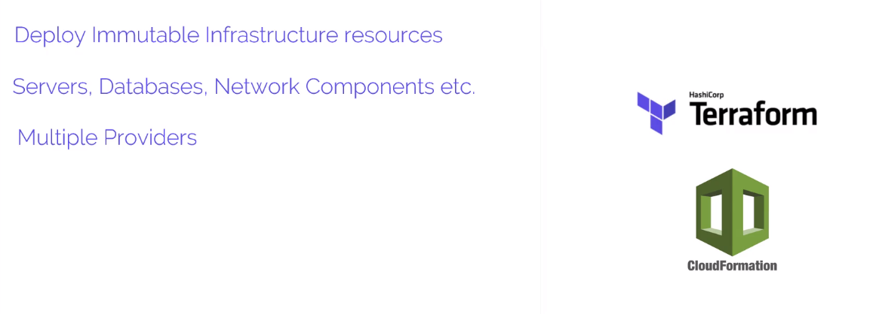

**What is Terraform?**

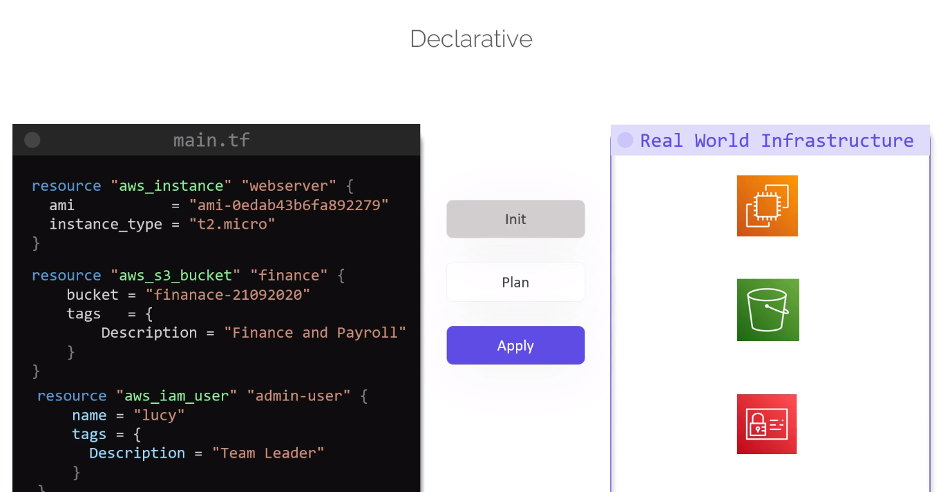

**Init phase:**

* During this phase terraform, initializes the project and identifies the providers to be used for the target environment

**Plan Phase:**

* During this phase, terraform drafts a plan to get to the target state

**Apply Phase:**

* Then in the apply phase, terraform make the necessary changes required on the target environment to bring it to the desired state
* Every object terraform manages is called a resource.
* Terraform manages the lifecycles of the resources from its provisioning to configuration to decommissioning.
* It ensures that the entire infrastructure is always in the defined state at all the time
* The state is the blueprint of the infrastructure deployed by the terraform
* Terraform can read attributes of existing infrastructure components by configuring data sources
* TF can also import other resources outside of TF that were created manually or by means of other IAC tools.

**Installing Terraform:**

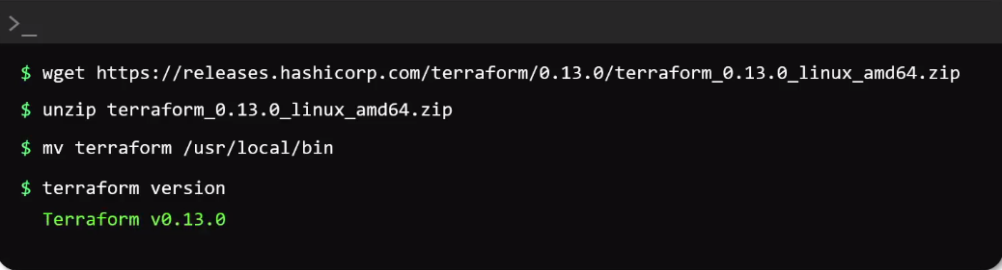

**HCL (HashiCorp Configuration Language) basics**

HCL file consist of Blocks and Arguments

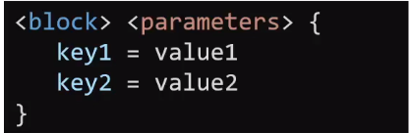

A Block in terraform in terraform contains information about the infrastructure platform and set of resources within that platform that we want to create

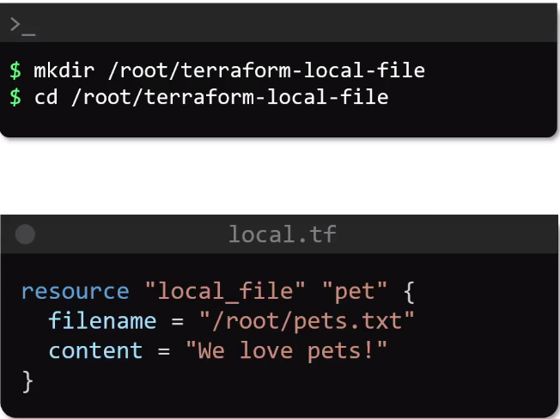

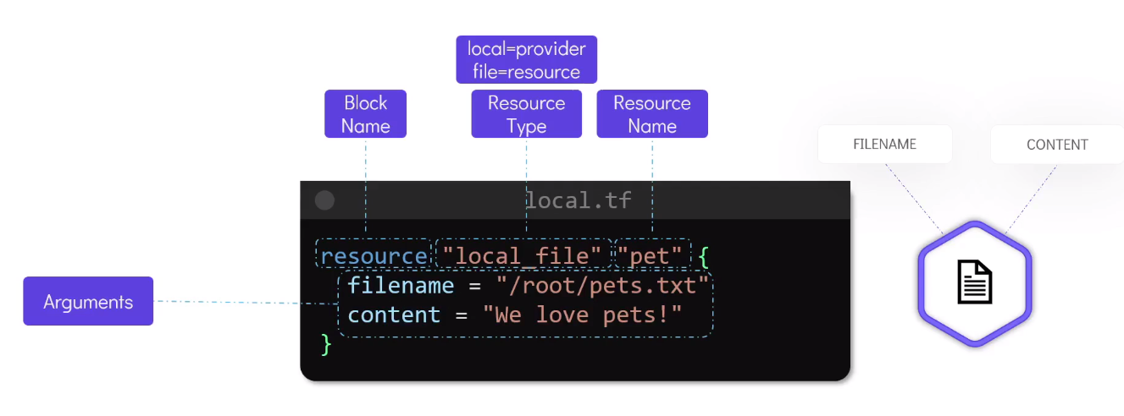

Resource file created for provisioning EC2 instance:

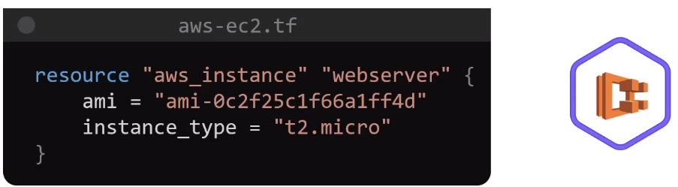

Resource file used to create AWS S3 buckets:

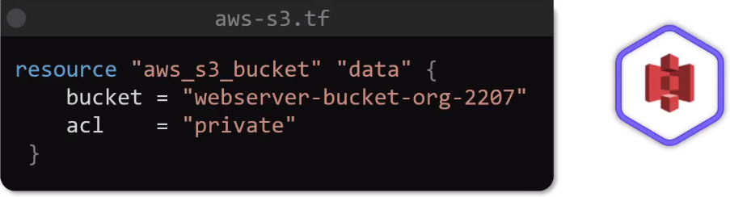

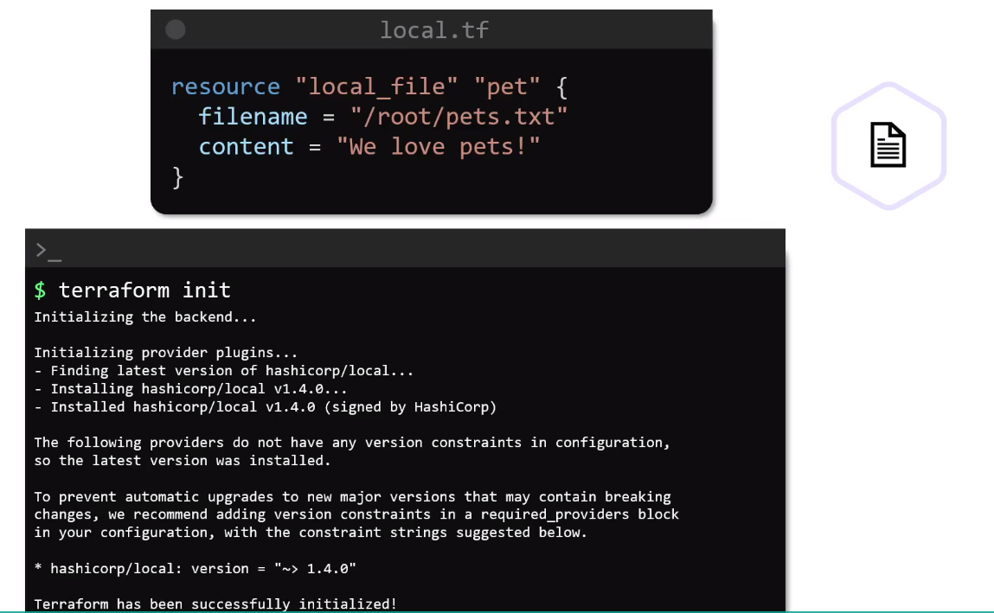

**Terraform init** command will check the configuration file and initialize the working directory containing the .TF file

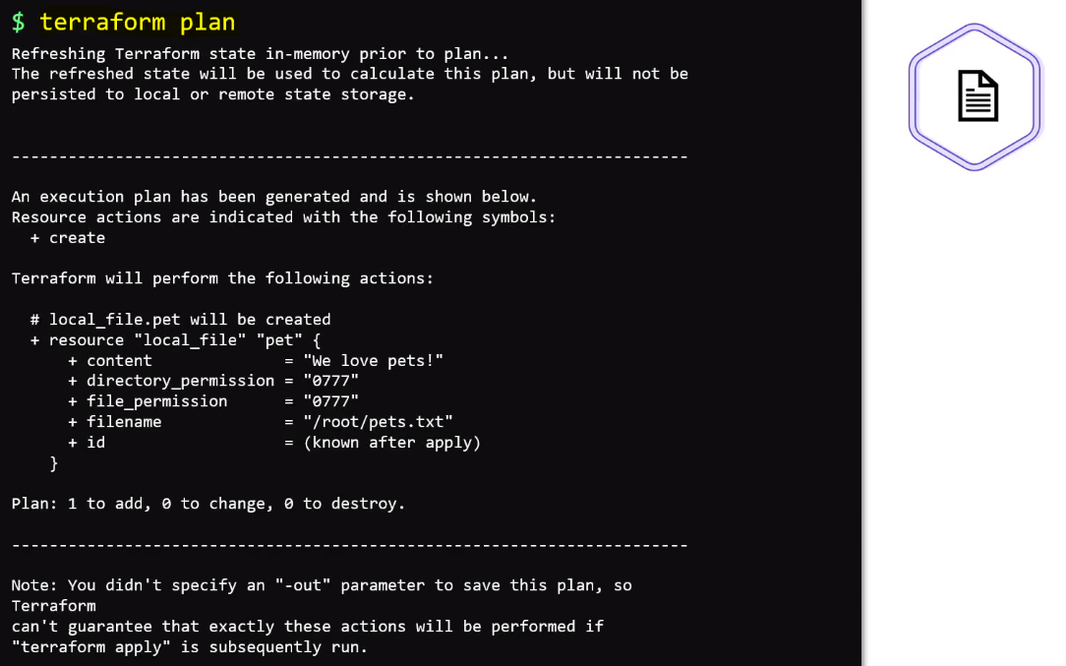

**Terraform plan** command will show the action that will be carried out by terraform to create the resource

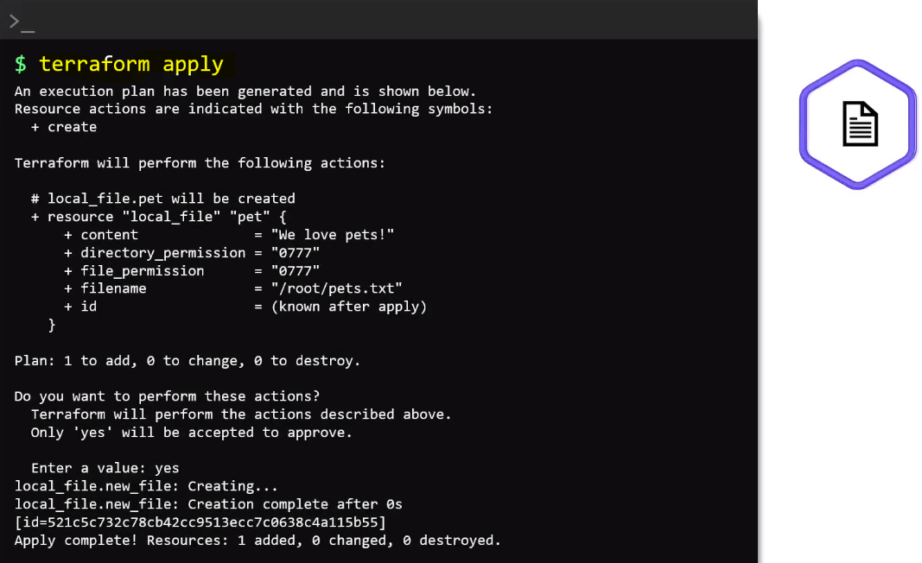

**Terraform apply** command will display the execution plan once again and it will then ask the user to confirm by typing YES to proceed. Once we confirm it will proceed with the creation of the resources which in this case is a file

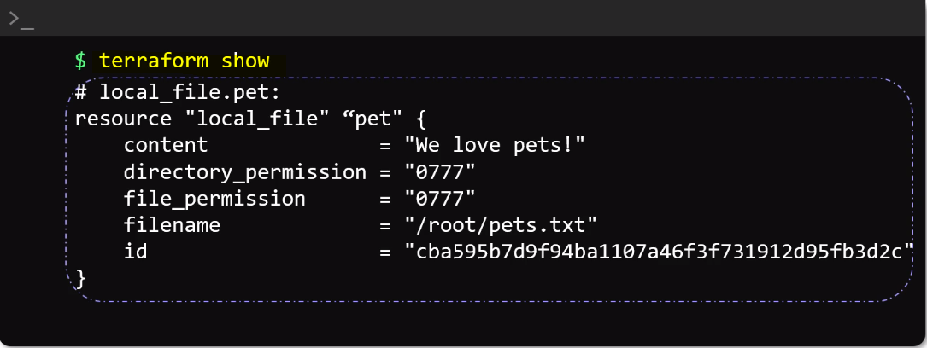

We can also run **terraform show** command in the directory to see the details of the resources we just created. It inspects the state file and displays the resource details

**Using Terraform Providers:**

* When we perform terraform init within a directory containing configuration files, terraform downloads and install plugins for the providers used within the configuration

**Variable Blocks:**

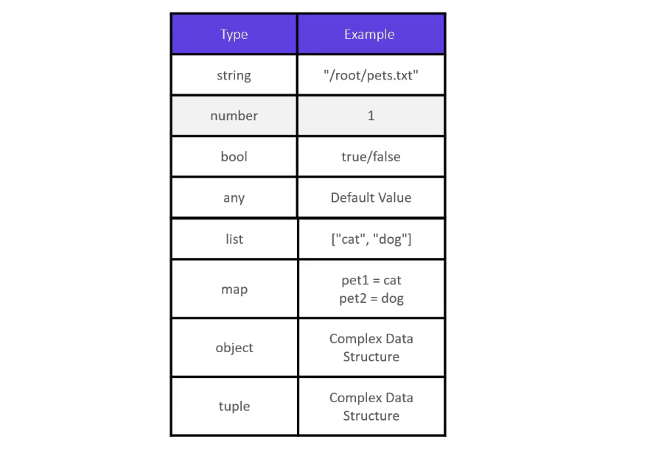

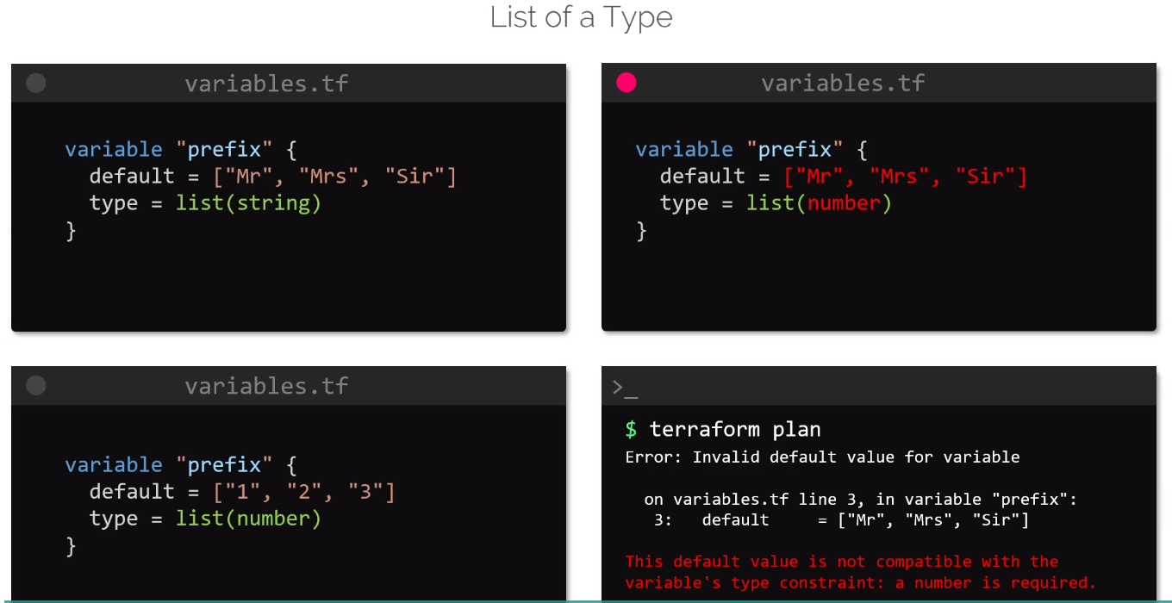

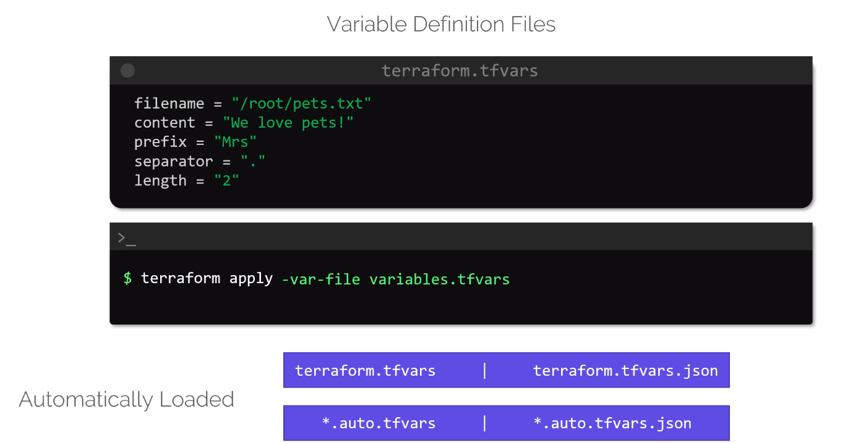

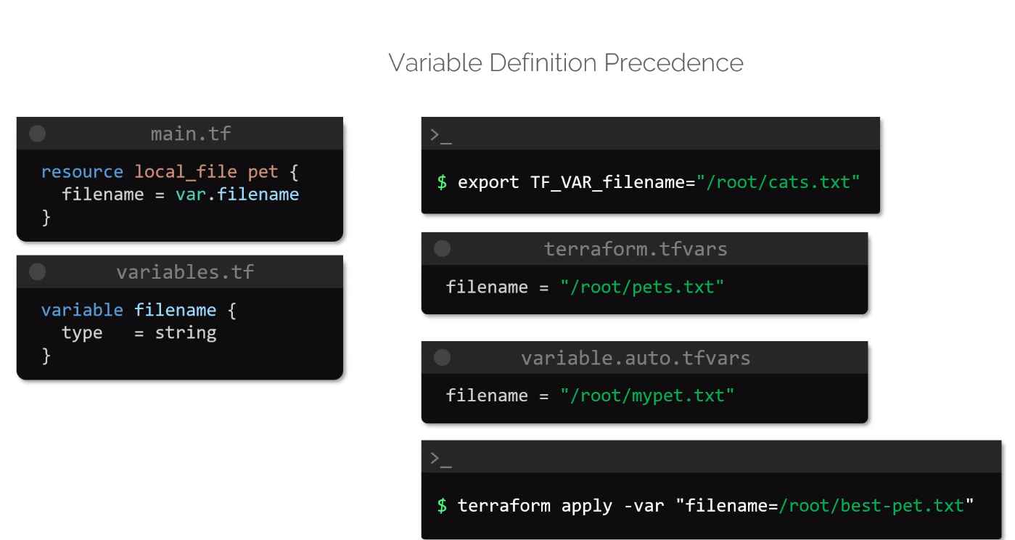

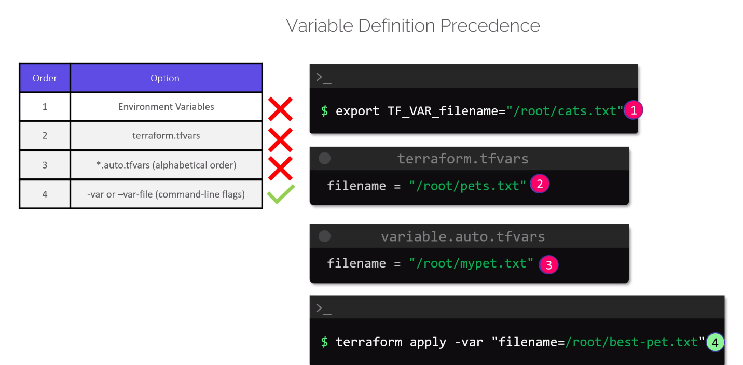

As you can see, the resource block is empty. This is because time_static does not need any arguments to be supplied to work.  
When applied as it is, terraform creates a logical resource locally (similar to random_pet) with the current time.

**Resource Dependencies**

* **Implicit Dependencies**

**local_file** first then **random_pet**

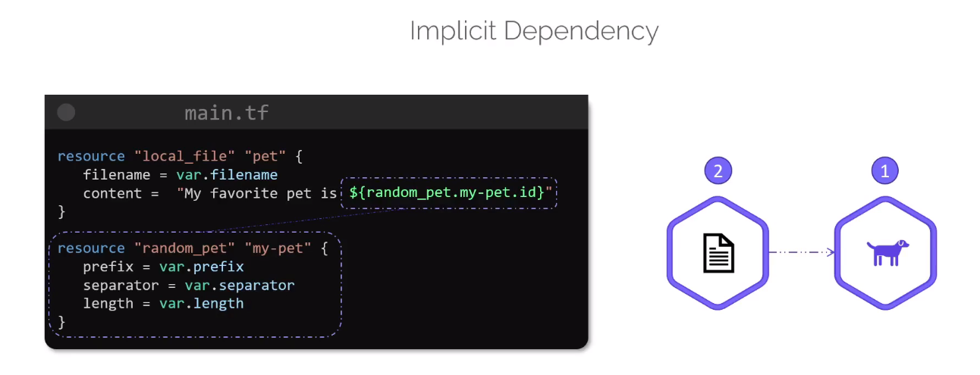

* **Explicit Dependencies**

**Local_file** is only created after **random_pet** file

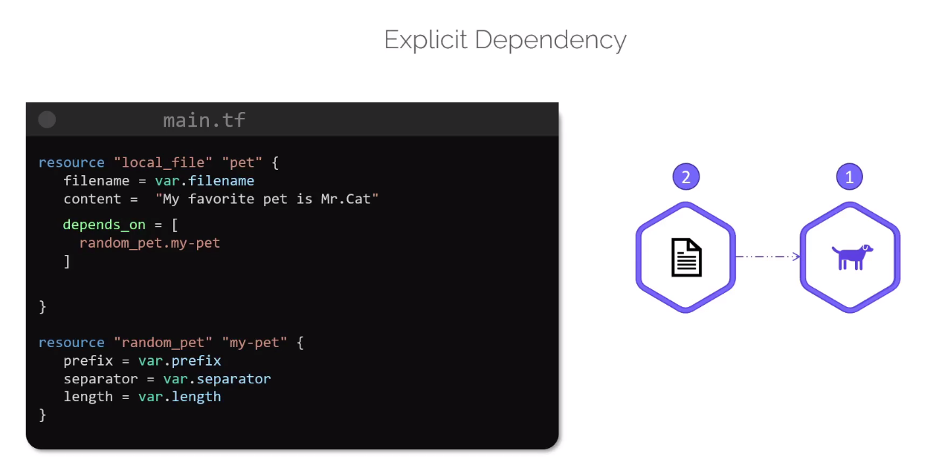

**Output Variables:**

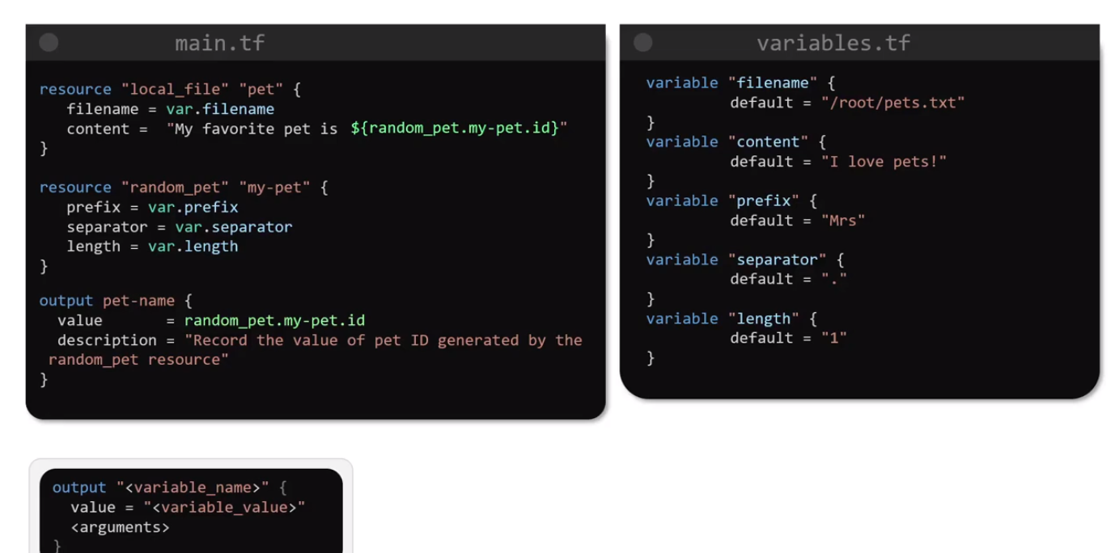

**Terraform State:**

* Terraform uses state file to map the resource configuration to the real-world infrastructure.
* This mapping allows terraform to allow create execution plan when a drift is identified between the resource configuration file and the state.
* State file can be considered a blueprint for all the resources that are out there.
* When tf creates a resource, it record its identity in a state.
* TF support 2 types of dependencies such as implicit and explicit.
* Besides the mapping between the resources and the configuration file and the real world, the state file also track metadata details such as resource dependencies .

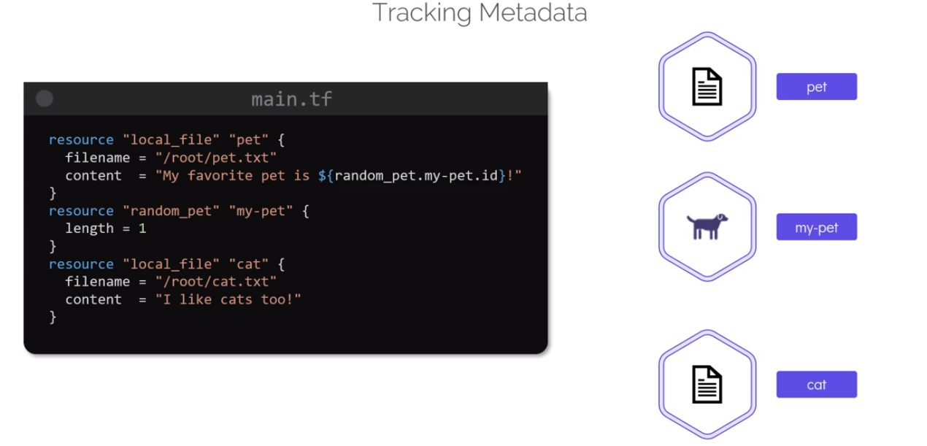

* We have 3 resources as seen in the above snippet
* First **my-pet** resource of random_pet and **cat** resource of local_file provider will be created.
* Resource name **pet** of local_file provider **will be created after random_pet** provider as it **depends** on it.
* Refer below snippet for understanding

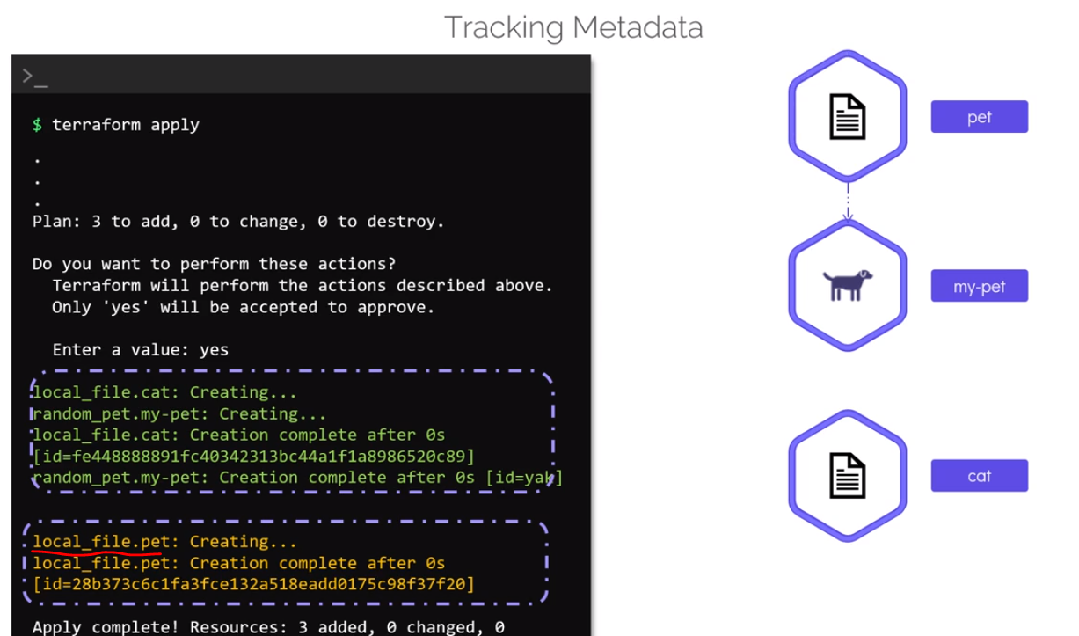

* What happens when we remove resource from the files?
* For example, we remove **random_pet** and **local_file pet** from the configuration file

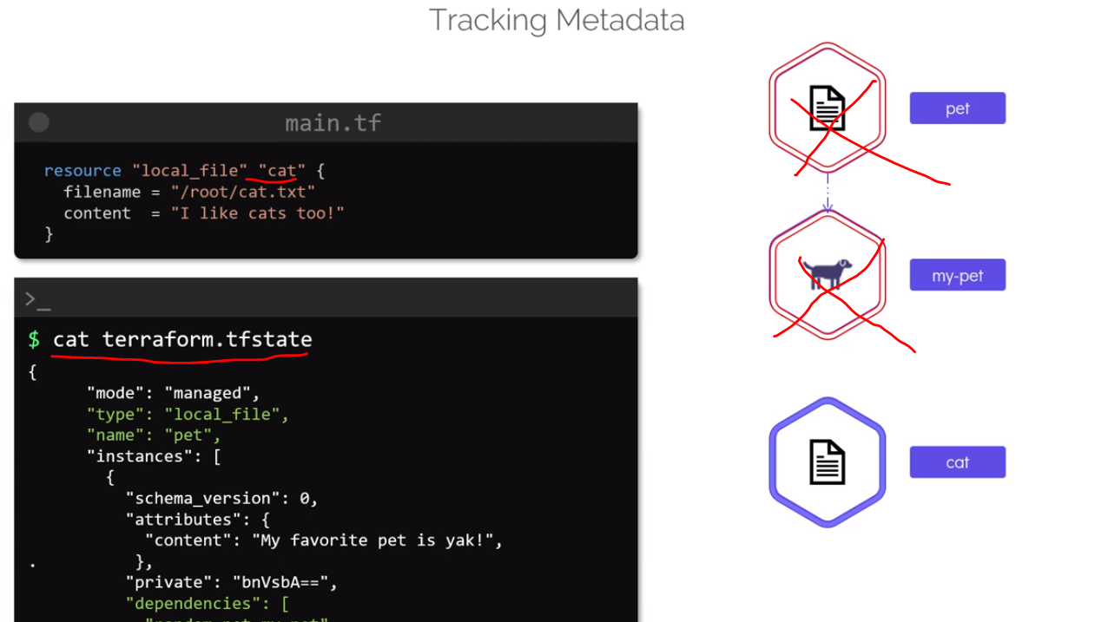

* If we were to apply the configuration now, TF knows that it has to delete these resources
* However, in which order does it delete it?
* The information about resource dependency is no longer available in the configuration file, as we have removed those lines from it.
* This is were **TF relies on state and the fact that its track metadata**
* Within the state file we can see **local_file** resource **pet** dependency on the **random_pet** resource.
* Since, these 2 resources has been removed from the configuration file, TF now knows that it should delete this **local_file** first followed by **random_pet** resource
* One other benefit of using **state is performance**
* When dealing with the handful number of resources, it may be feasible for terraform to reconcile state with the real-world infrastructure after every single TF cmd such as plan and apply.
* In real world TF manages hundred and thousands of such resources.
* When these resources are distributed to multiple providers and especially those that on cloud, it is not feasible for TF to reconcile state for every TF operation.
* For large infrastructure this may prove to be too slow
* In such cases, the TF record can be used as the record of truth without having to reconcile, this will improve the performance significantly
* **TF stores a cache of attribute values for all resources in the state**
* We can specifically **make TF to refer to the state file alone** while running commands and **bypass** having to refresh state every time
* To do this, we can make use of **-refresh=false flag** with all the TF commands that make use of state

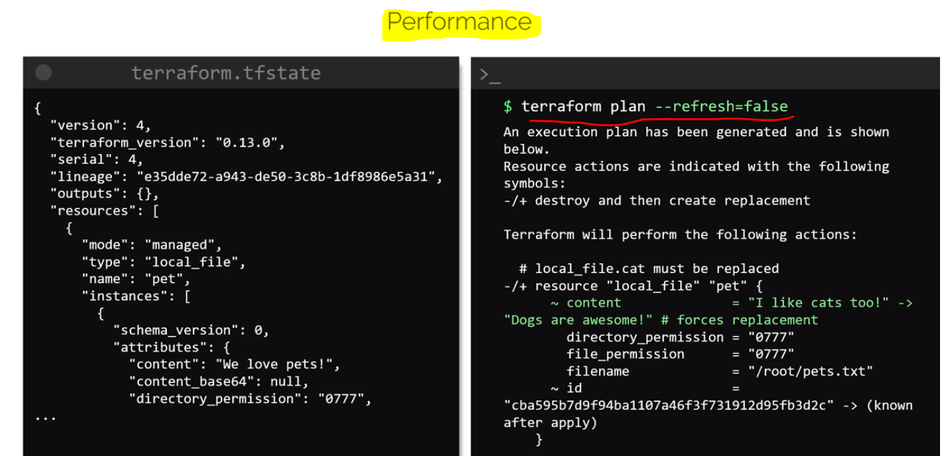

* When we run the plan with this flag, you can see that **TF does not refresh state**.
* Instead, it relies on cache attributes and in this example the content which has changed in this configuration file and as a result, the execution plan plots a resource replacement
* The last benefit of state is **collaboration**
* The state file reside in configuration directory, so if it’s on local system it should not be used by two people at the same time.
* The best practice to edit and used is from remote location so that team members will be using the latest file updated

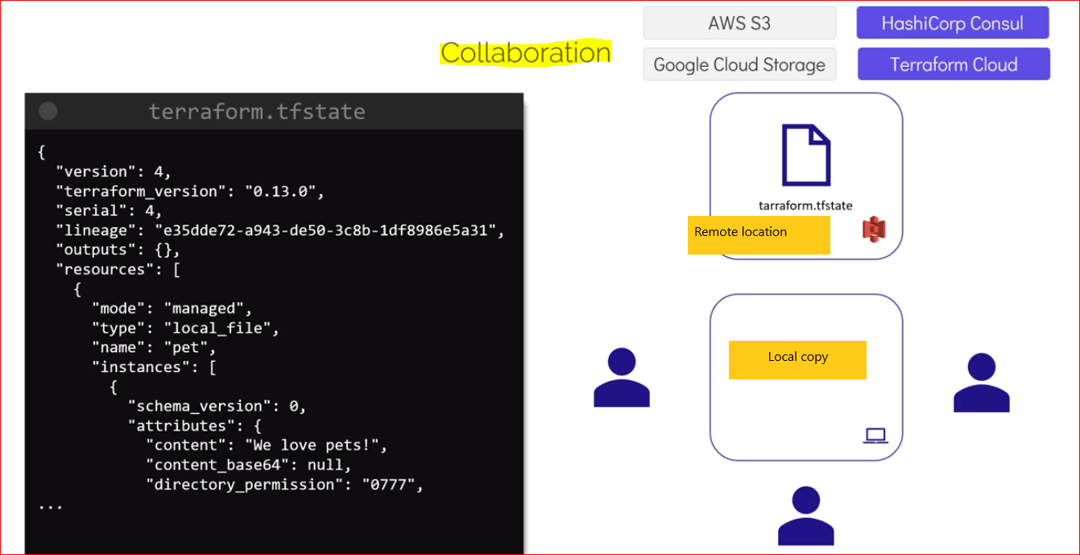

* The directory store **configuration** and **state** file
* The **state file contains sensitive information**.
* It’s best to store configuration file in version control systems such as **GitHub**, **GitLab** and **Bitbuckets**

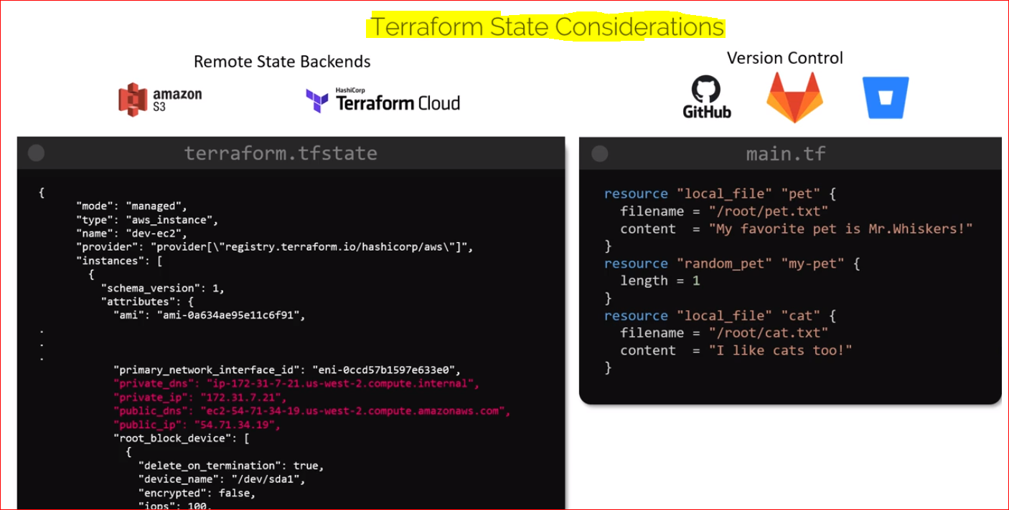

* However, owing to the sensitive nature of the state file it is not recommended to store it on GIT Repositories instead **store state file on remote state backends** such as Amazon S3, Terraform Cloud, Azure storage and GCP storage etc.

**Terraform Commands**

* **Terraform validate** (syntax: terraform validate)
  + It’s not necessary to perform TF plan and apply command to verify syntax.
  + We can do it with TF validate command.
  + If everything is correct in the file, we will see successful validation message
* **Terraform format command** (syntax: terraform fmt)
  + This cmd scan the configurations files in the current working directory and formats the code in the canonical format.
  + Useful cmd to improve readability of the TF configuration file
* **Terraform show command** (syntax: terraform show)
  + It prints out the current state of the infrastructure as seen by the terraform
  + We can use the JSON flag to print the output in JSON format **eg: terraform show -json**

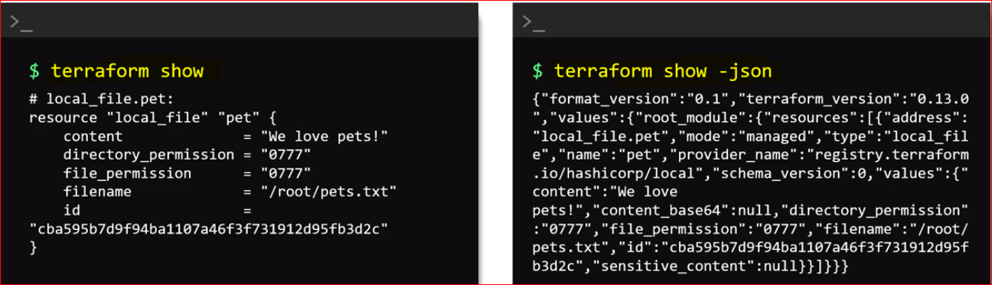

* **Terraform provider command** (syntax: terraform provider)
  + To see the list of all providers used in the configuration directory
  + Can also make use of **mirror subcommand** to copy provider plugins needed for current configuration
  + This cmd will mirror the provider configuration in a new path

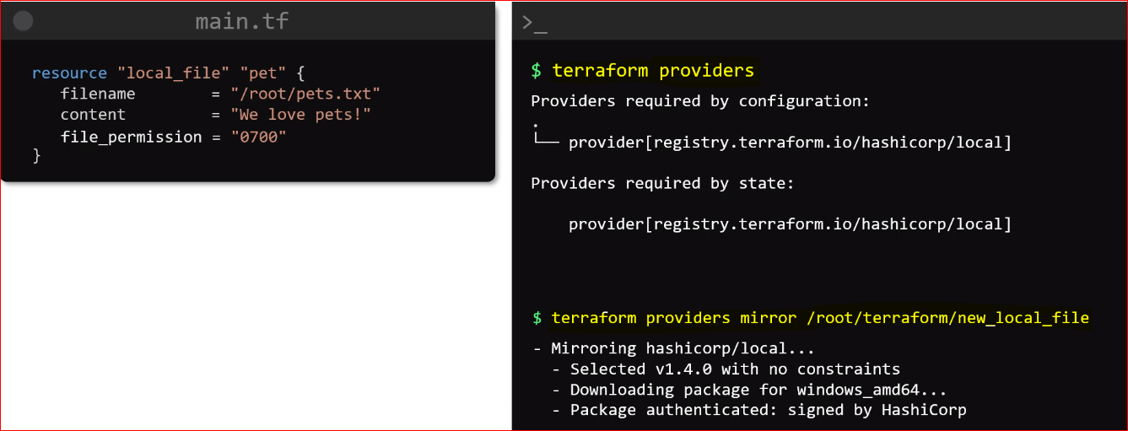

* **Terraform Output Command** (syntax: terraform output)
  + If you want to print all output variables in the configuration directory
  + You can also print the value of a specific variable by appending variable name at the end of the output command

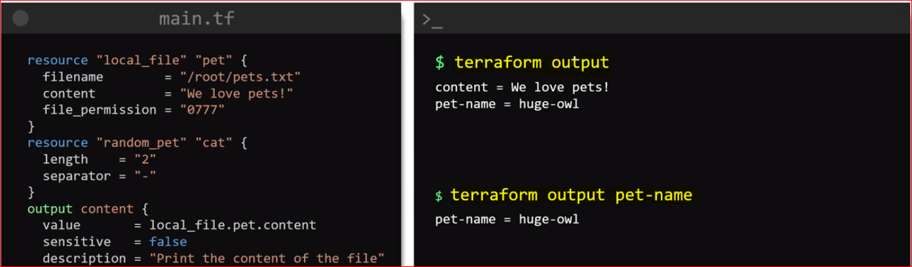

* **Terraform Refresh Command** (syntax: terraform refresh)
  + It is used to **sync** terraform with the real-world infrastructure
  + This cmd will not modify any infrastructure but will modify state file
  + It run automatically with terraform plan and apply command

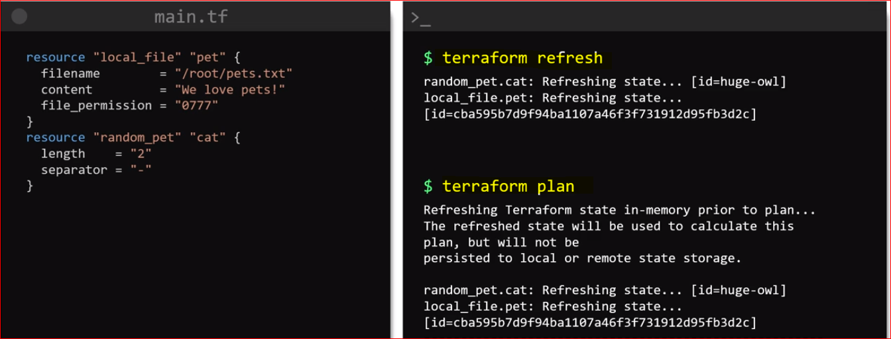

* **Terraform Graph Command** (syntax: terraform graph)
  + It is used to create a **visual representation** of the dependencies and a terraform configuration or an execution plan
  + For more sense pass it through a graph visualization software such as **GraphViz**. We can install it in ubuntu by using apt cmd

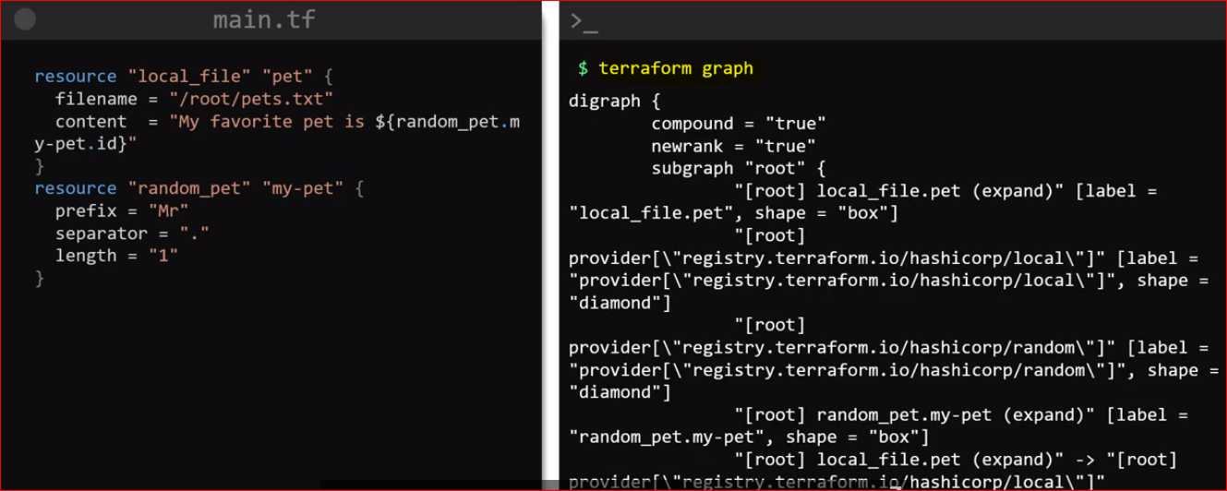

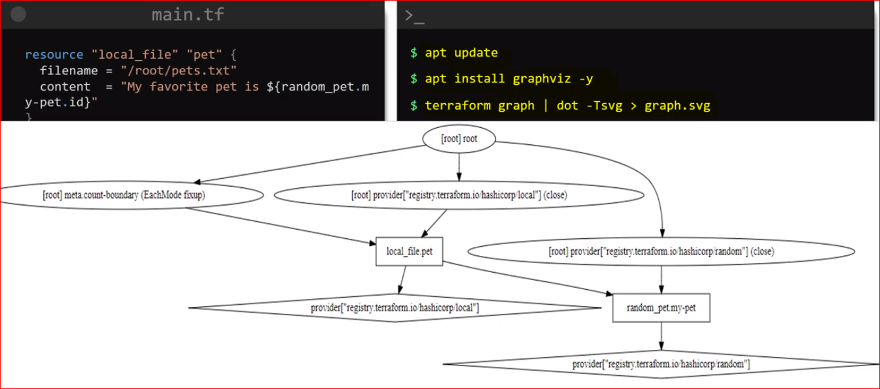

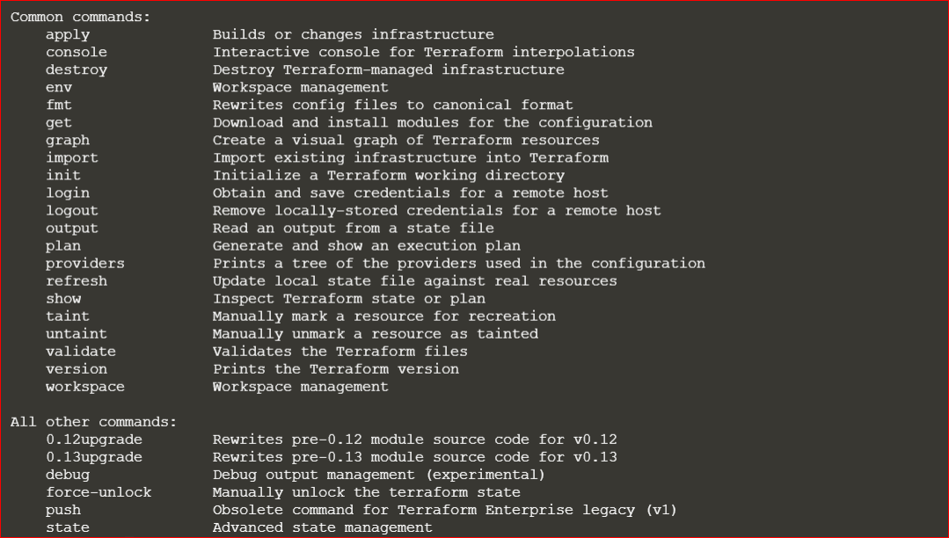

**Labs:**

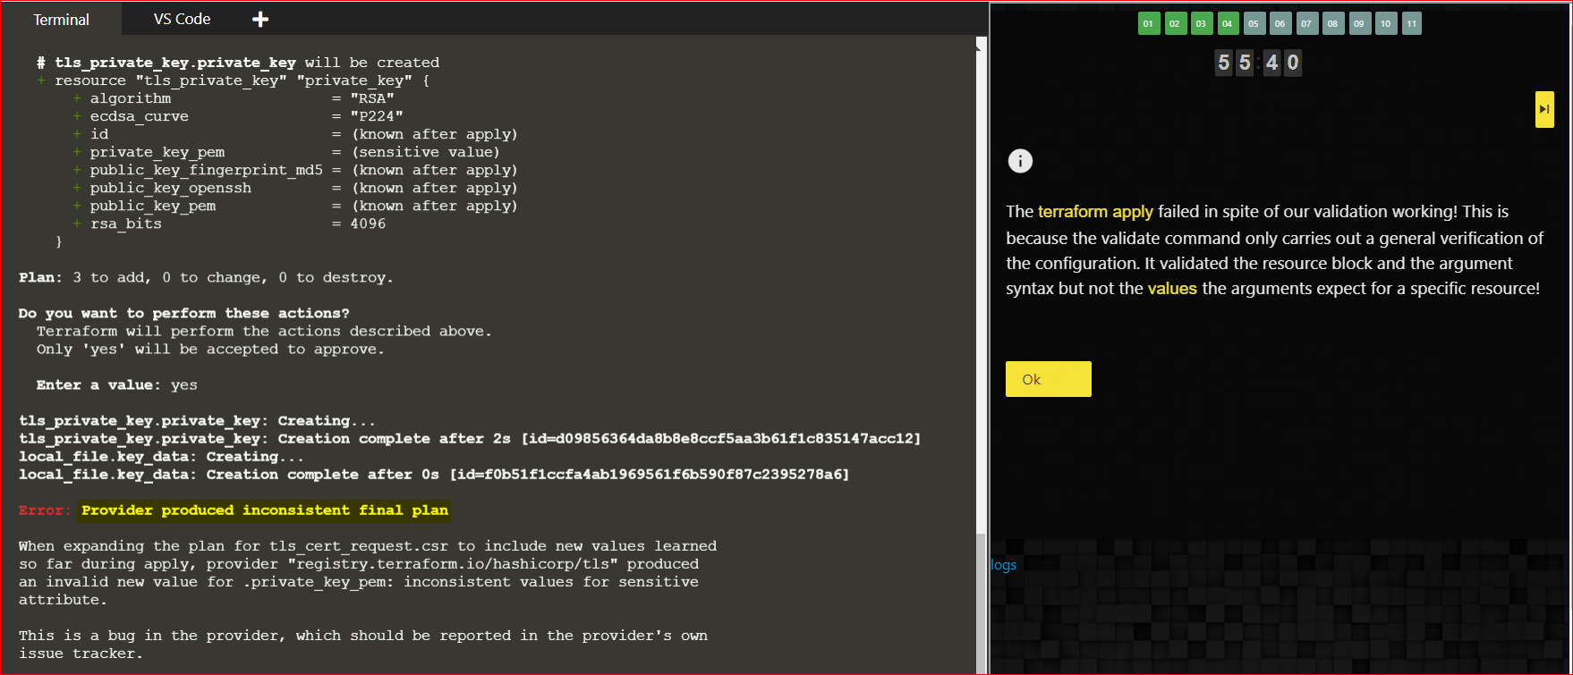

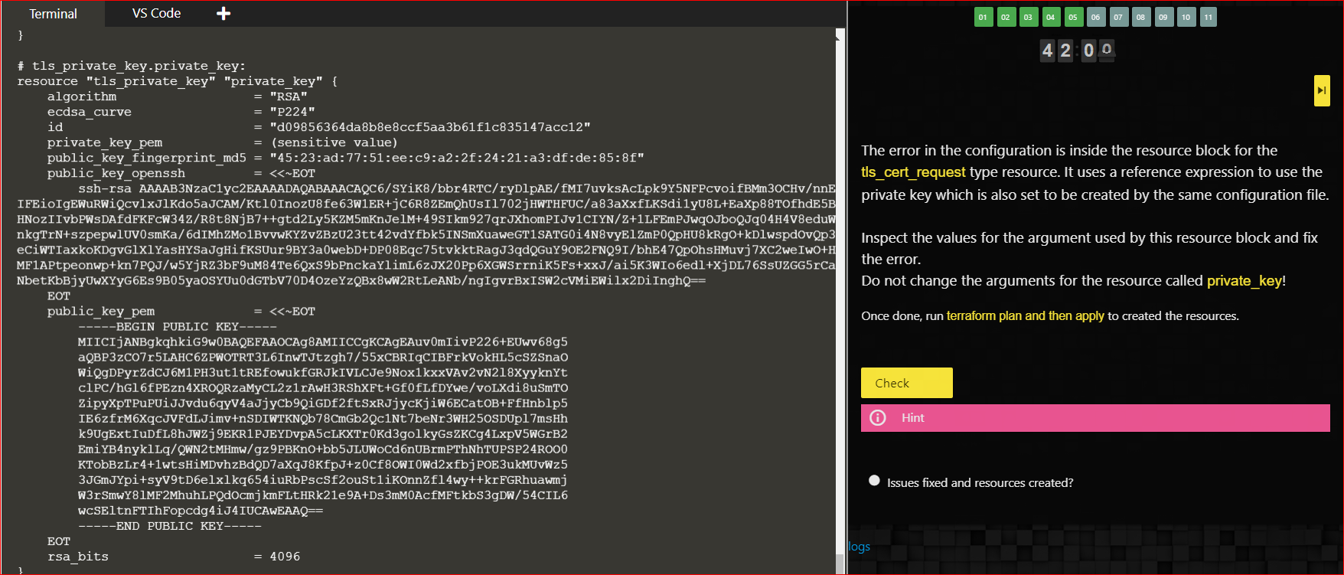

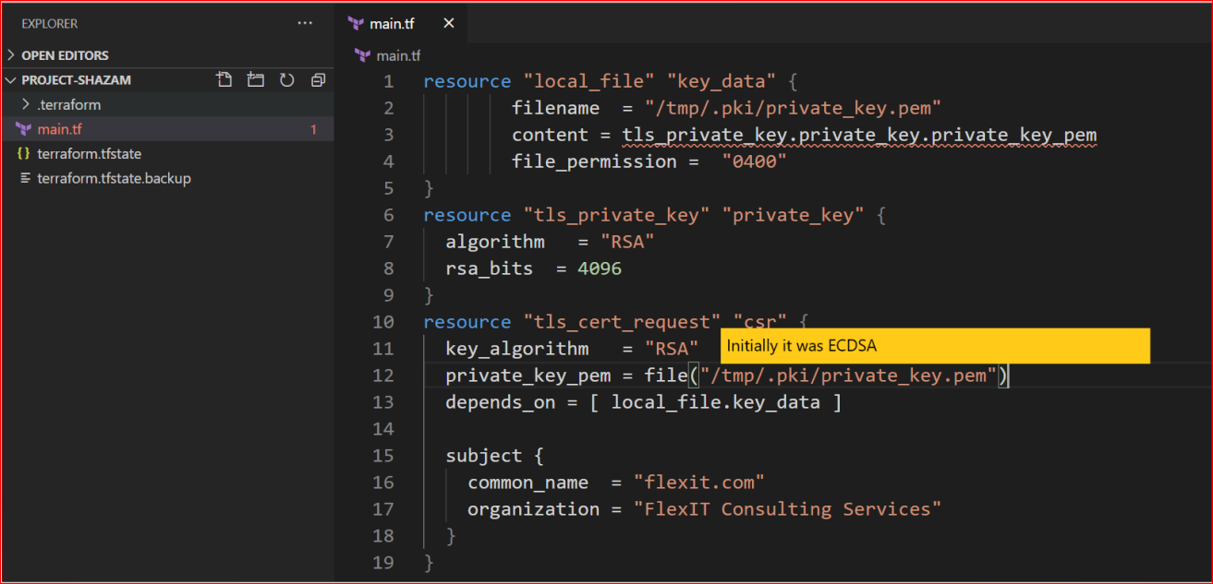

**Mutable Vs Immutable**

TF first deletes the older file then creates new one if any changes has been made to the file

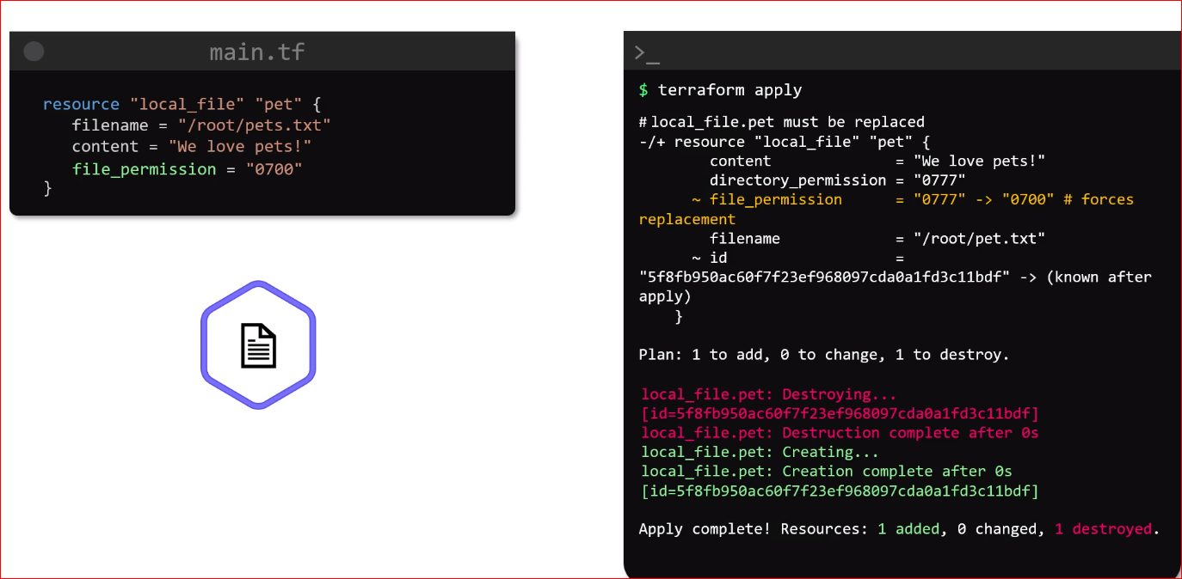

**Lifecycles Rule**

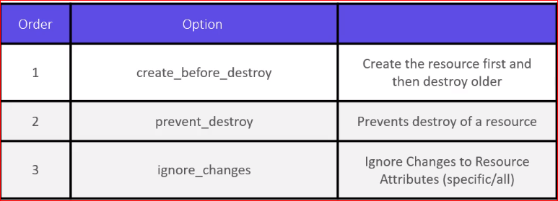

**NOTE: Once lifecycle has been added we must always run TF apply only nothing else**

* What if you want resources to be created first then delete older one or you don’t want to delete resources at all even if there was changes made in configuration file
* This can be achieved in TF by making use of **lifecycles**
* Add lifecycle rule **create_before_destroy** in resource block itself where we need to make changes as shown below, it will create resource first then delete the older one.

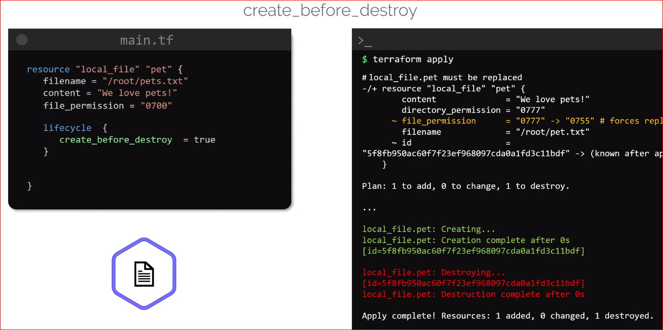

* There could be cases to were we do not want to destroy resource at all, we can make use of **prevent_destroy** option
* When it is set to true TF will reject any changes that will result in resource getting destroyed and display an error message as shown below:

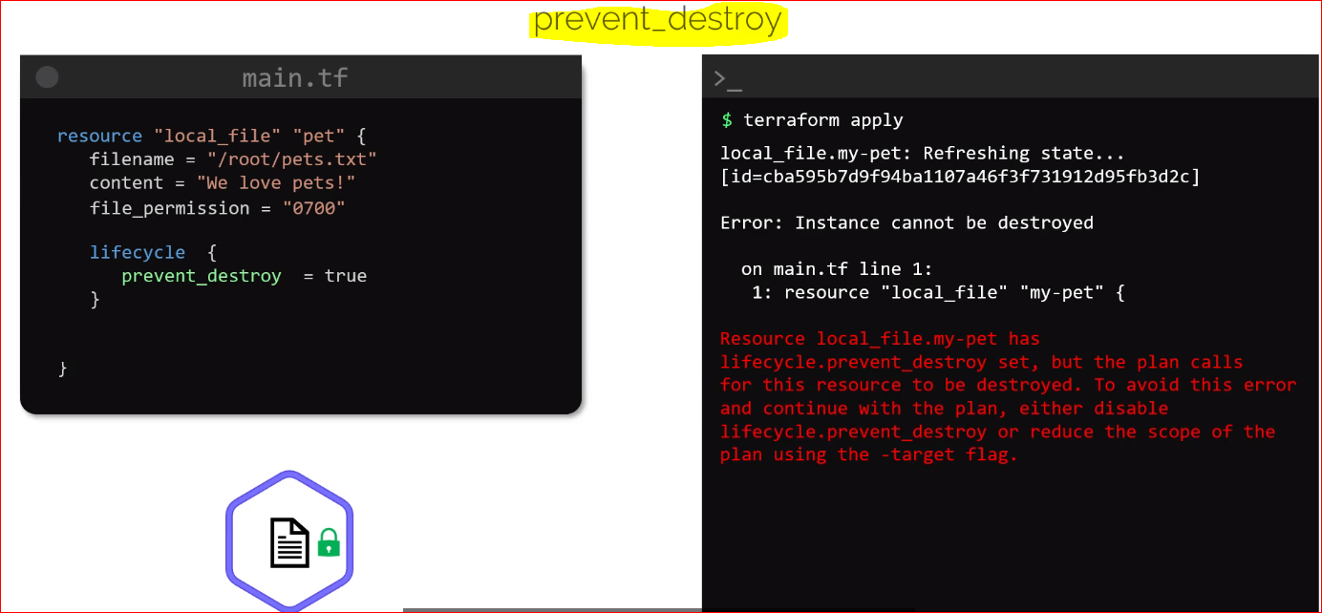

* The last lifecycle is **ignore changes** rule, this lifecycle when applied will prevent a resource from being updated based on list of attributes that we define within a lifecycle block
* **Example**:

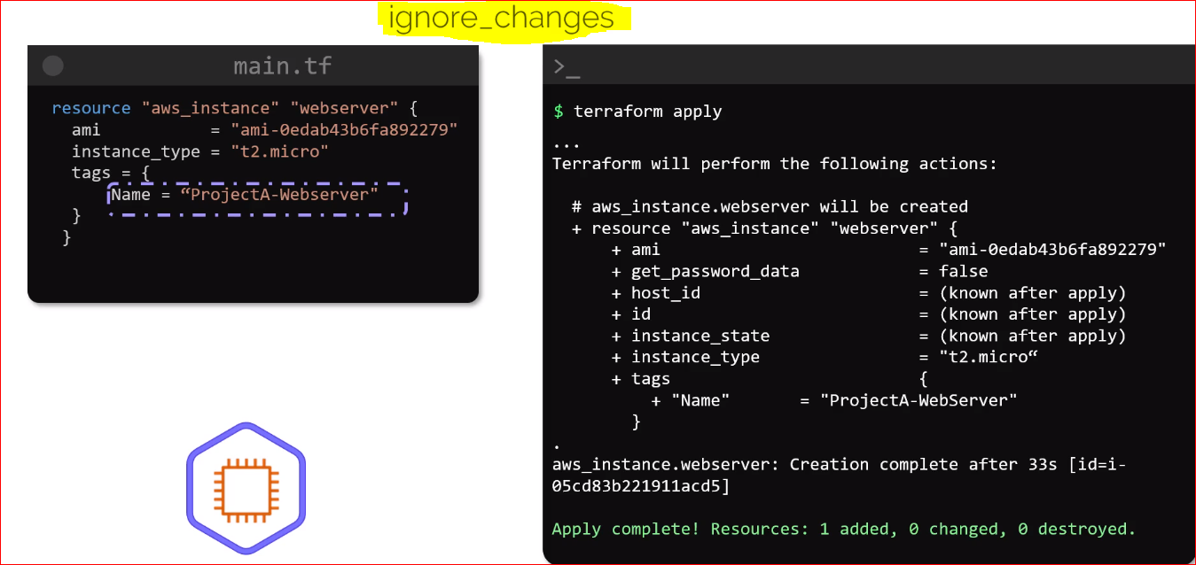

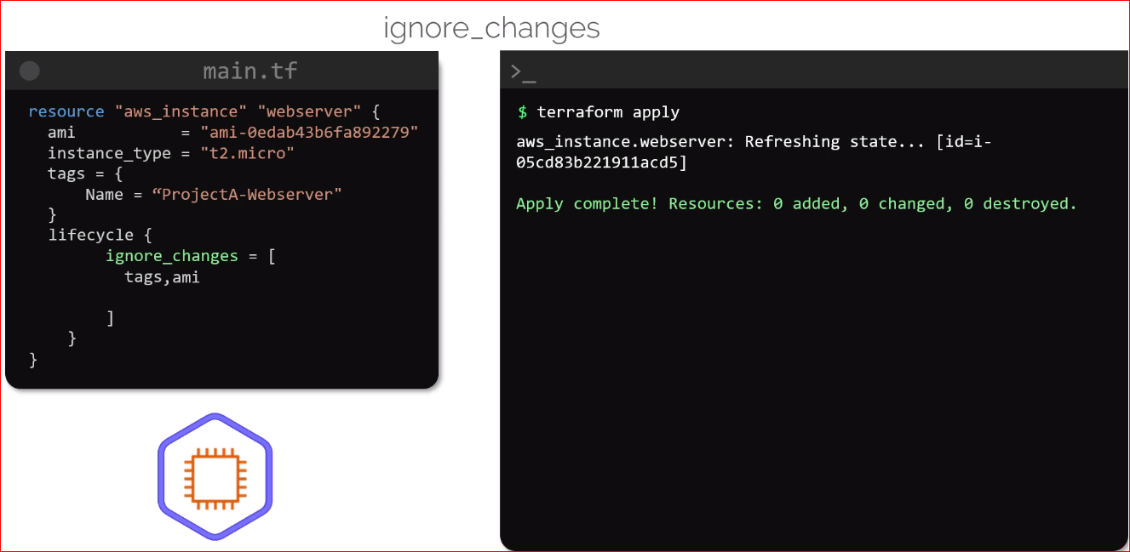

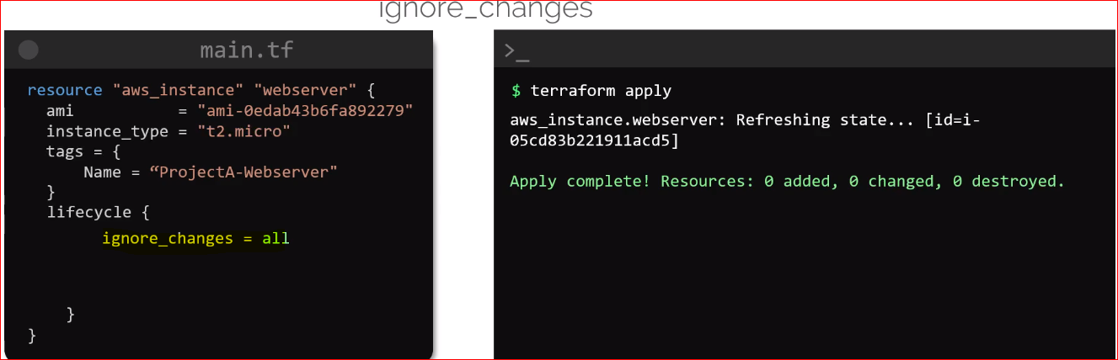

* We can also use **ignore_changes** to **all** this is useful when we do not want the resources to be modified for changes in the resource attributes

Labs:

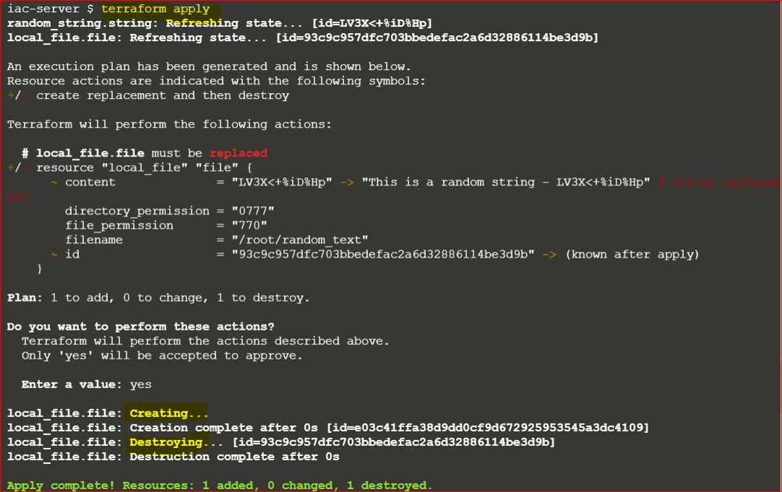

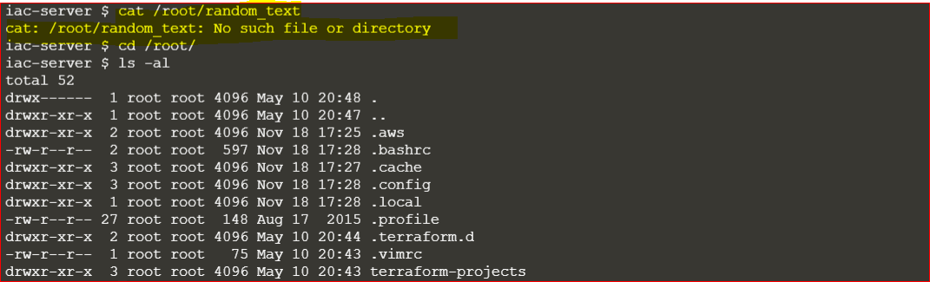

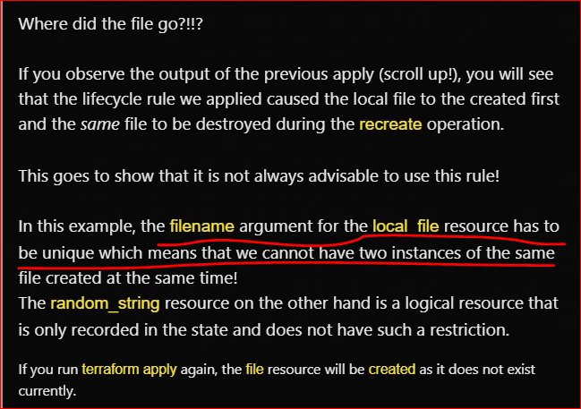

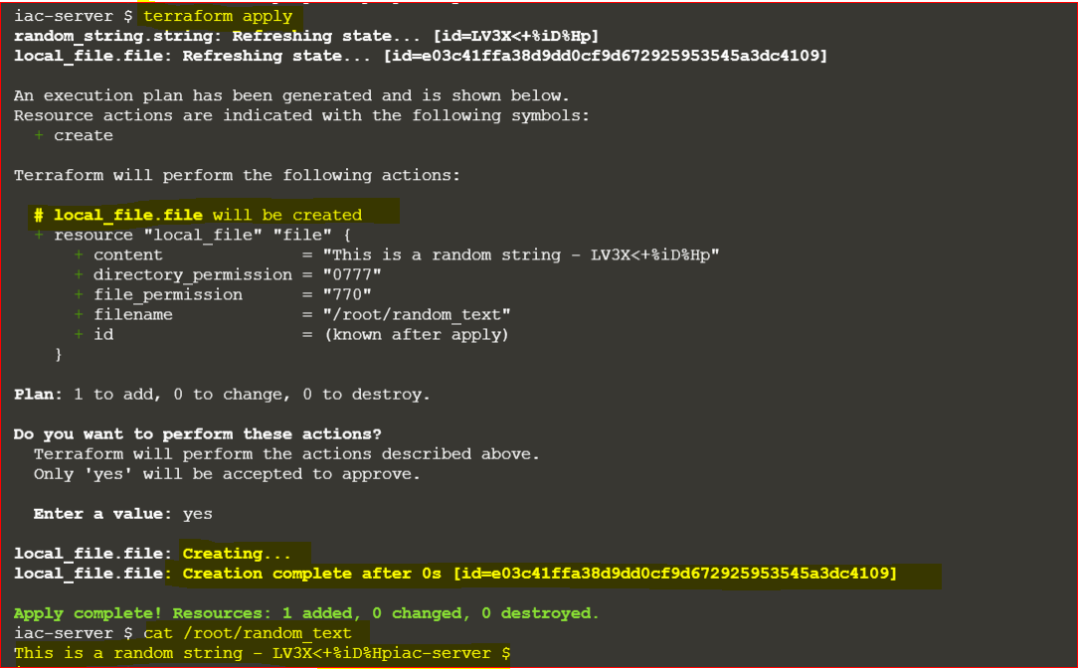

**Datasources**

* Datasources allow TF to read attributes from resources which are provisioned outside it control

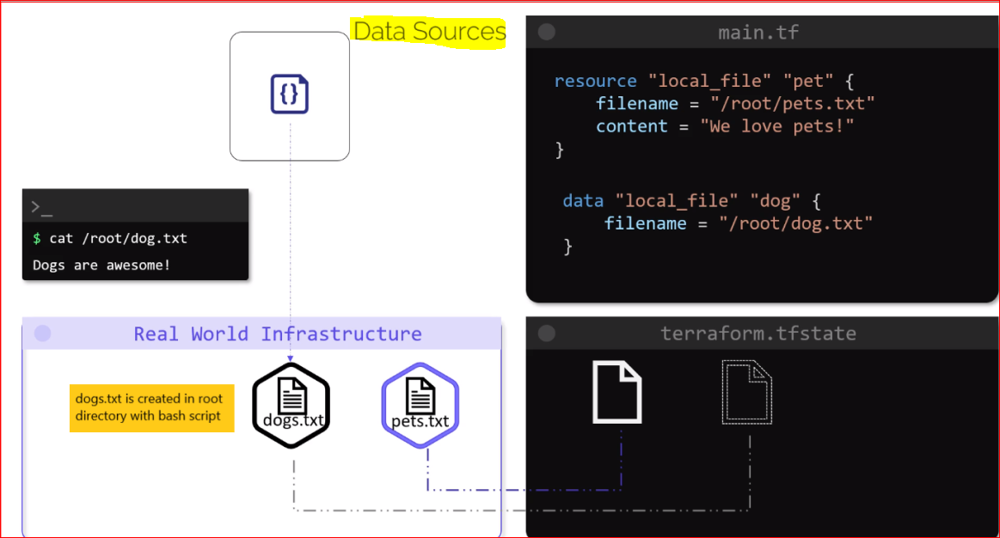

* The data read from data source is then available under the “**data-object**” in TF
* To use this data in a resource called **pet**, we could simple use **data.local_file.dog.content** as shown below:

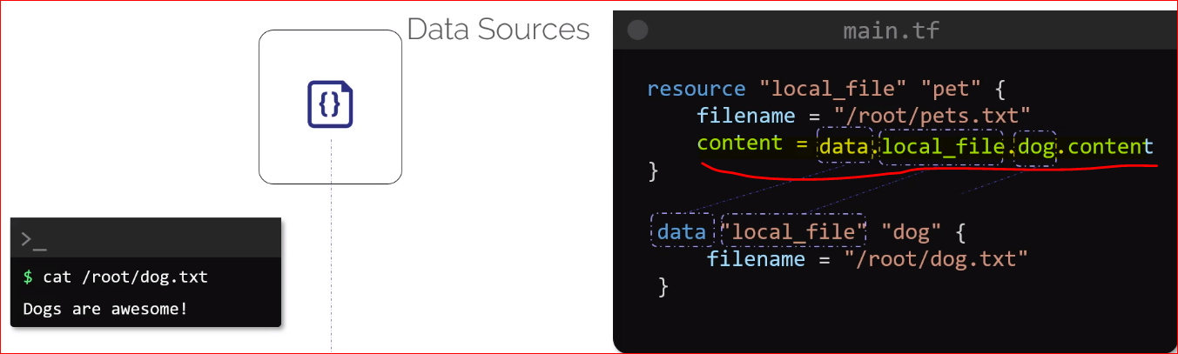

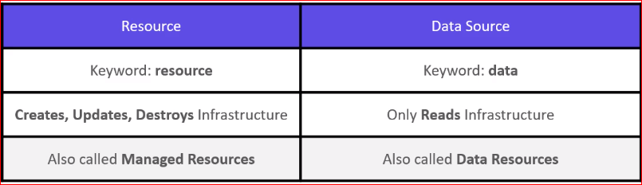

**Datasource Labs:**

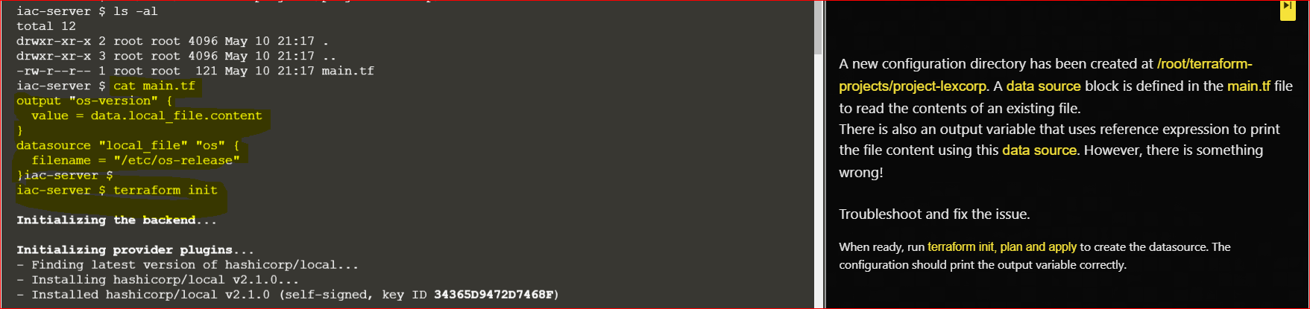

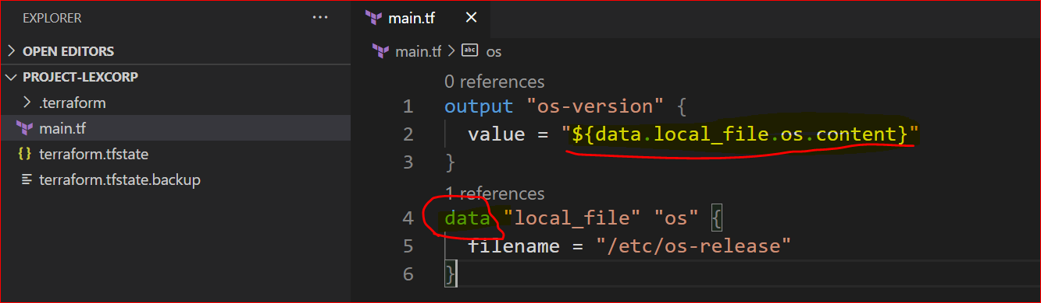

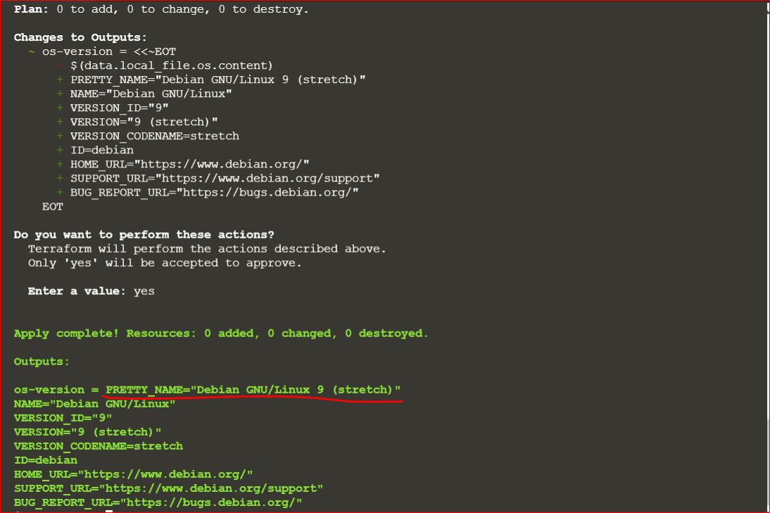

**Meta-Arguments:**

* Creating 3 resources of same type is easy with shell script as we apply for loop and it will create 3 file
* We cannot use that For loop command in resource block of terraform
* This can be done y using a specific meta argument in TF
* Meta argument can be used within any block to change the behaviours of resources
* We have already seen below 2 meta argument as of now

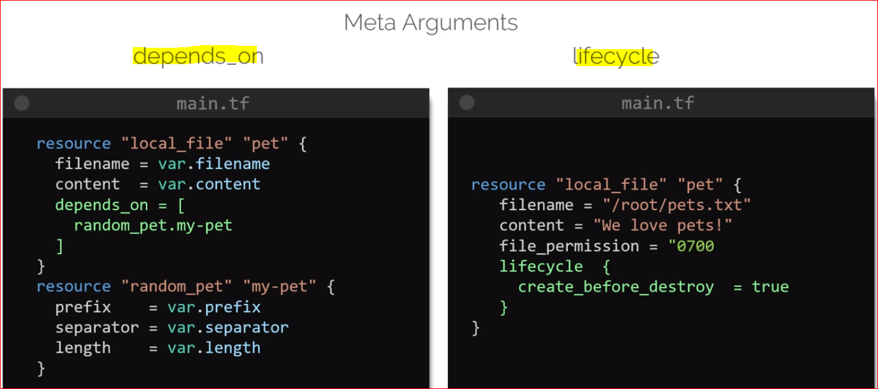

* **Count meta argument**
* We can create multiple resources just by adding count = 3 in our TF resource block

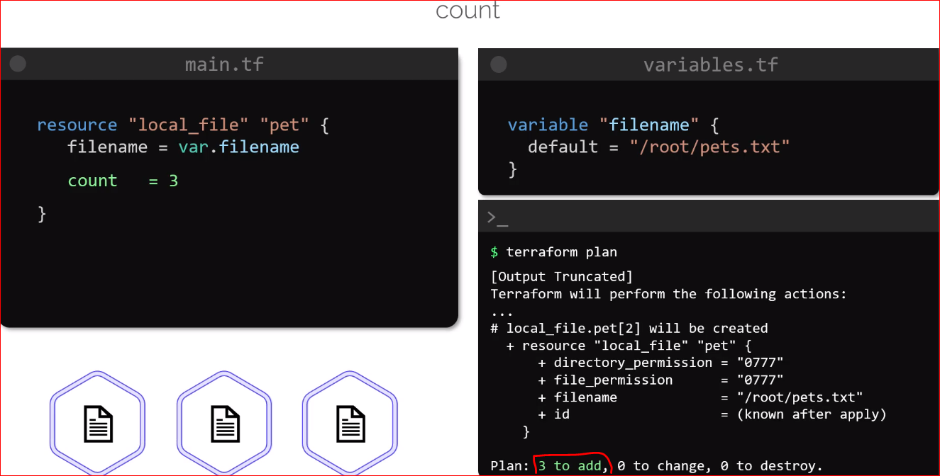

* TF will create 3 files when we run Terraform init cmd as pet[0], pet[1], pet[2]
* But if we see the /root directory we can see only one file that is pet.txt as TF has created the same file 3 time as the name of file was not unique
* If we create 3 files with different name and add **count.index** as **filename index** as shown below it will create three files:

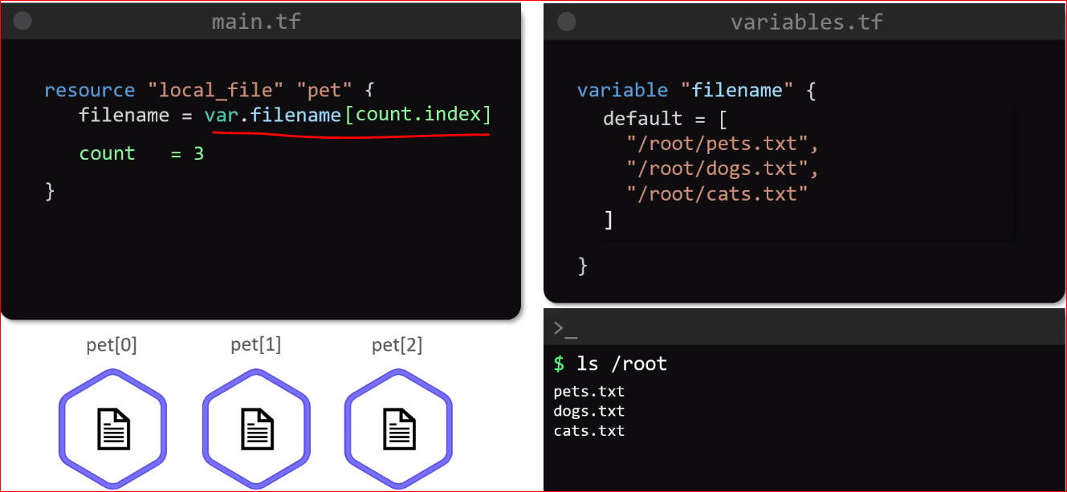

* What if we add 2 more file as shown below and run TF apply it will still create 3 files as count is 3 in main.tf file
* We can use length function to dynamically determine the size of the filename variable as shown below:

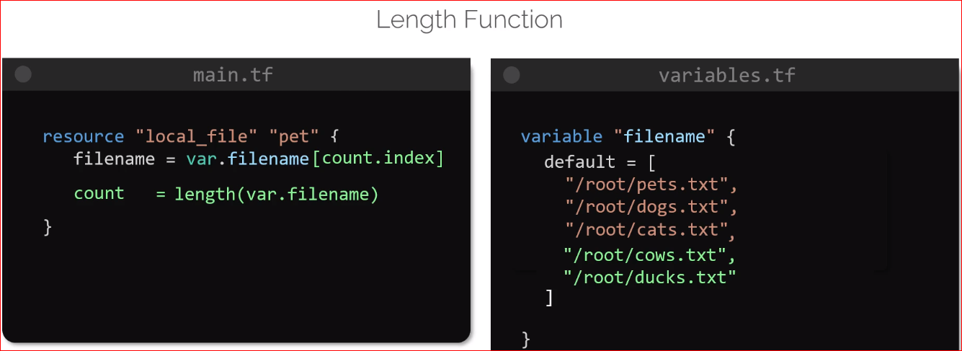

* If we remove pet.txt and run TF apply it will destroy dogs.txt and cats.txt as well
* This happens due to index as shown below
  + Pets.txt 🡪 index 0
  + Dogs.txt 🡪index 1
  + Cats.txt 🡪 index 2
* When pets.txt is removed , dogs.txt move to index 0 and cats.txt move to index 1and due to change of this TF apply consider it as change in configuration file as shown below:

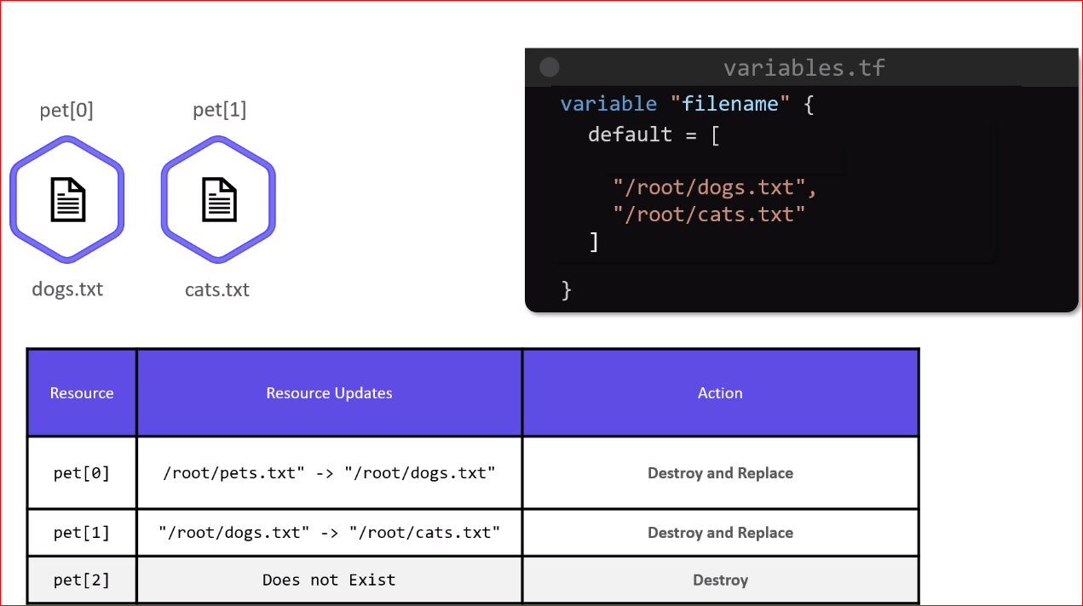

* **For-each meta argument**
* When we used count the resources are created as list and this can have undesirable result when updating them
* One way to overcome this is to use **for-each** cmd instead of **count**

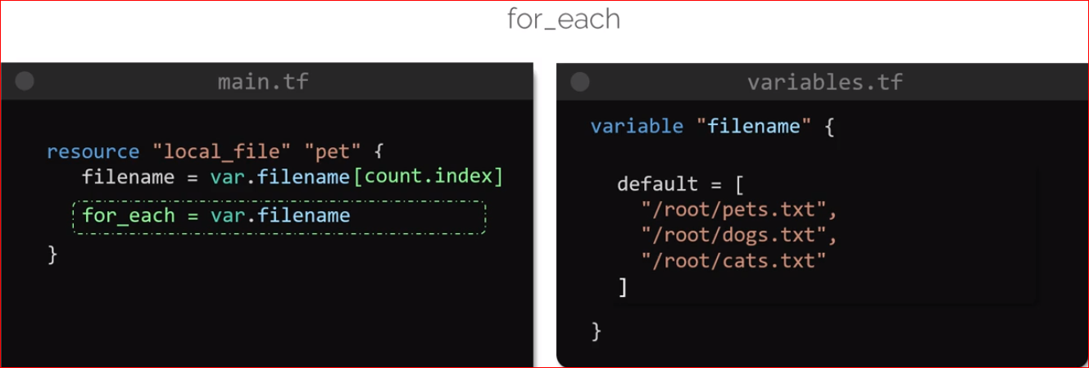

* To set the value of filename to each element in the list we can make use of expression **each.value**
* If we run a TF plan now we will see an error as shown below:

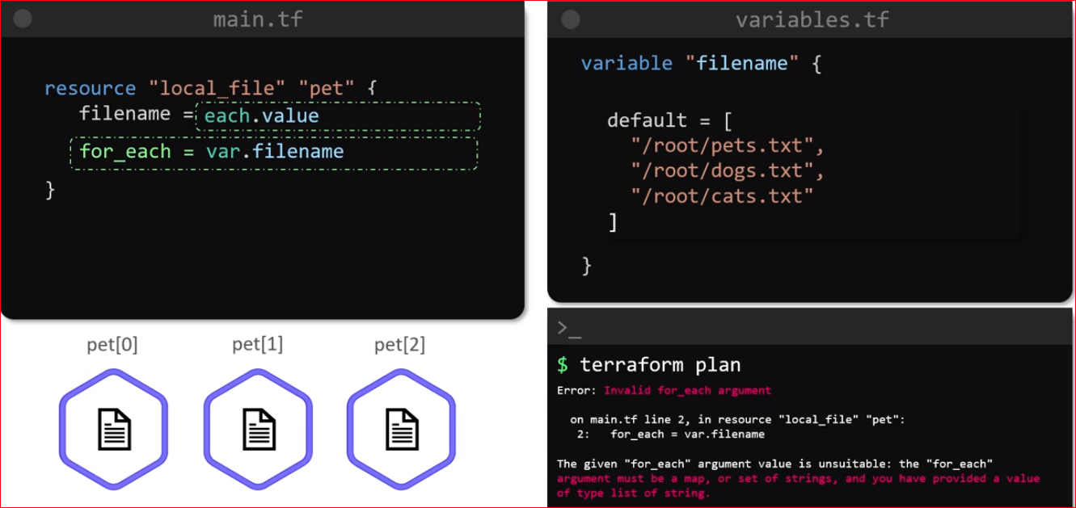

* The **for-each** argument only works with **map** or a **set**
* One way is we can change **type** to **set(string)** in variable.tf file as shown below:

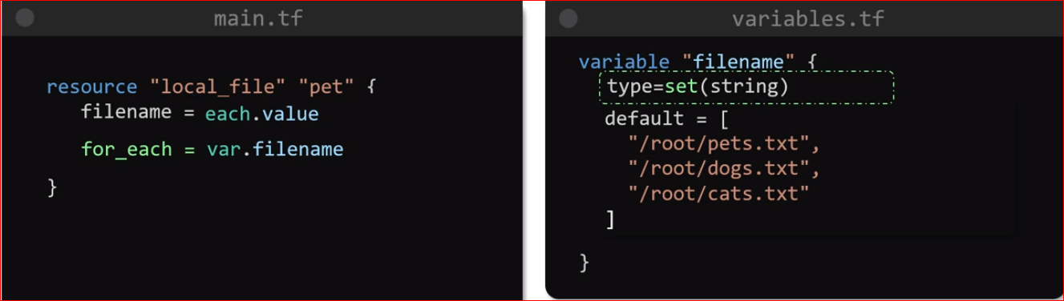

* Now if we try TF plan it will work
* Another way to fix this error while retaining the variable type as list is to make use of built-in function that is **toset() function which** will convert the list type into set type

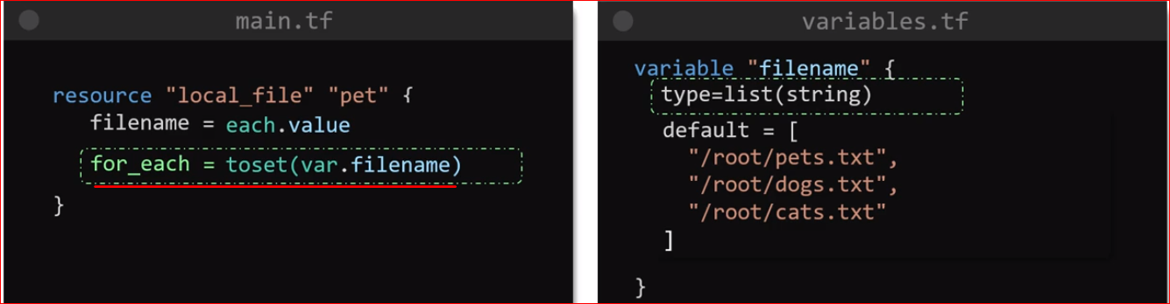

* Once this is done TF plan cmd should work as expected
* If we remove pets.txt again and try to run terraform plan cmd again it will **destroy only one resource that is pets.txt** as shown below:

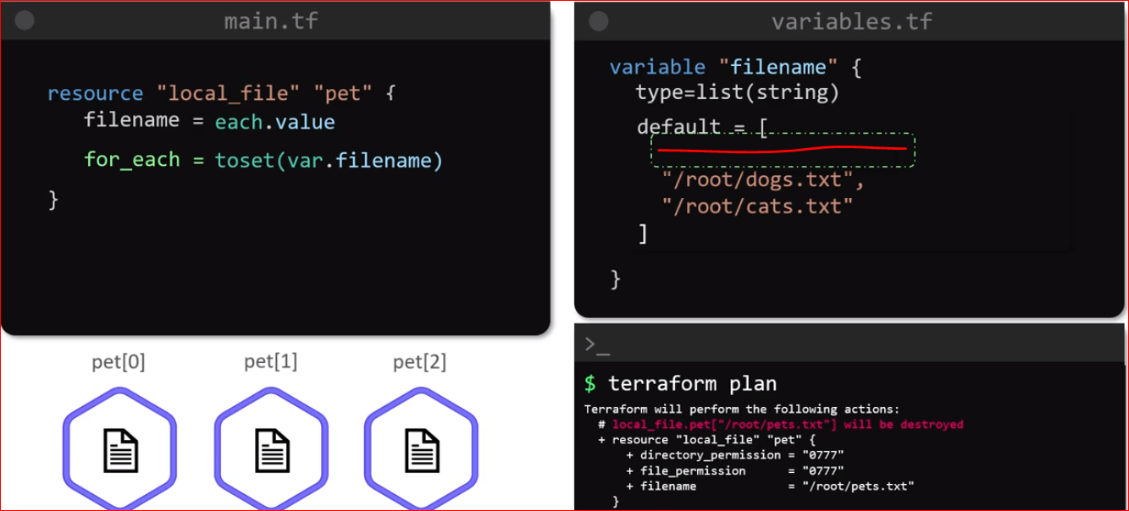

* When we add output variable and perform terraform output we can see below output as map and not as list
* When we use **for-each** instead of **count** the resources are created as a **MAP** and not as a **LIST**
* This means **resources are no longer identified as index** that we saw while count
* They are now **identified by keys** which are filename /root/..txt or cats.txt which are used by the for-each argument in the configuration file

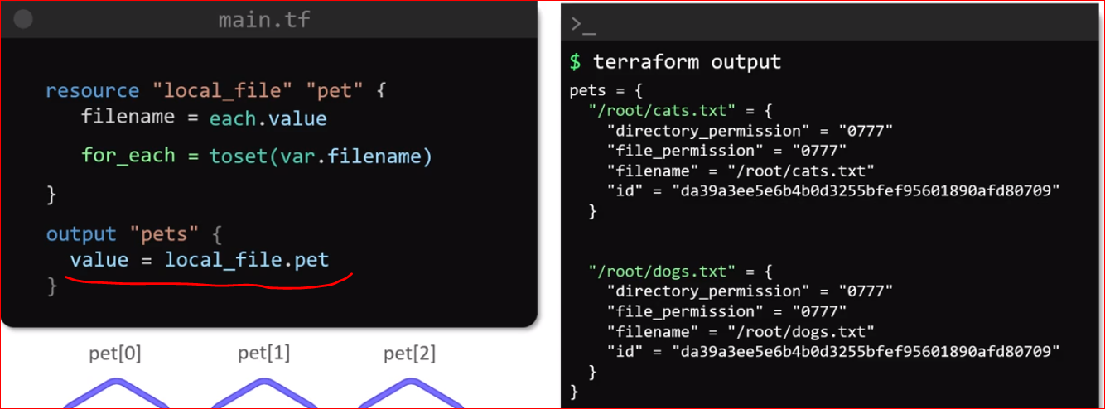

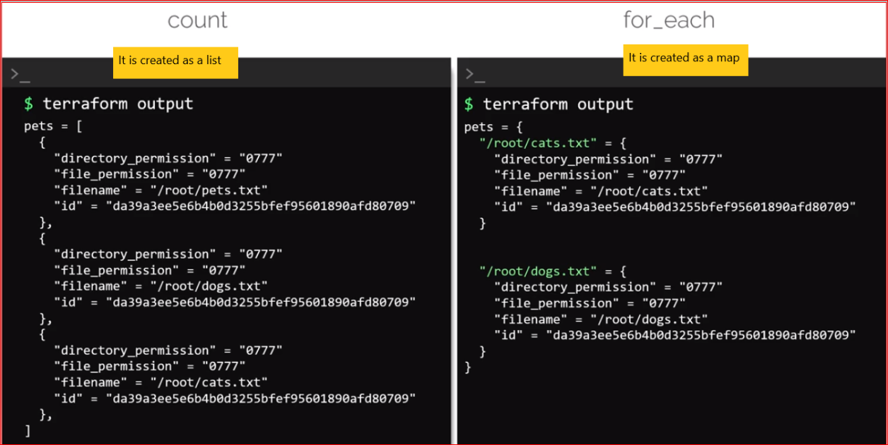

* There are few others meta arguments in TF such as provisioners, providers, backends etc

Version Constraints

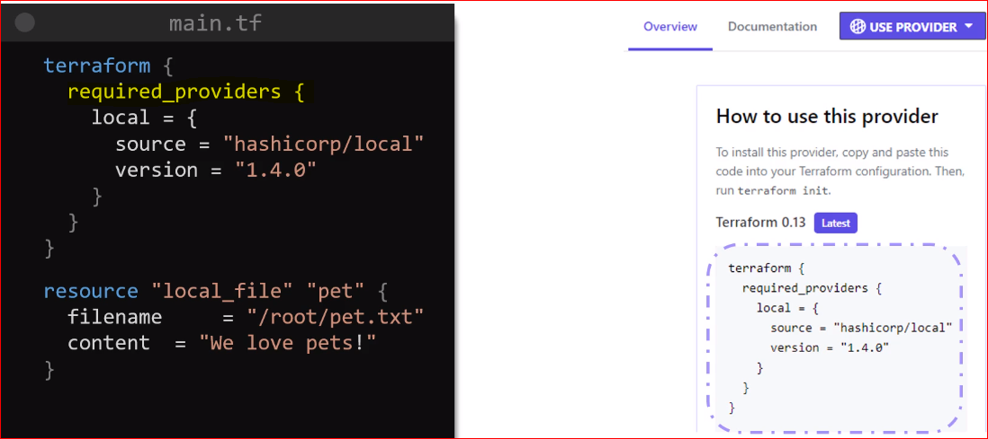

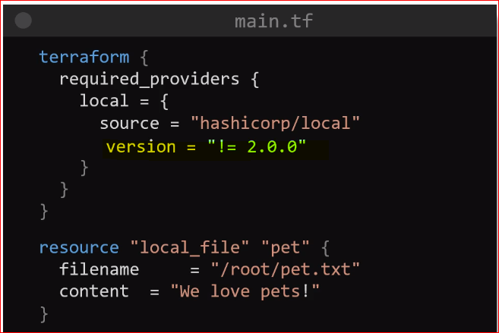

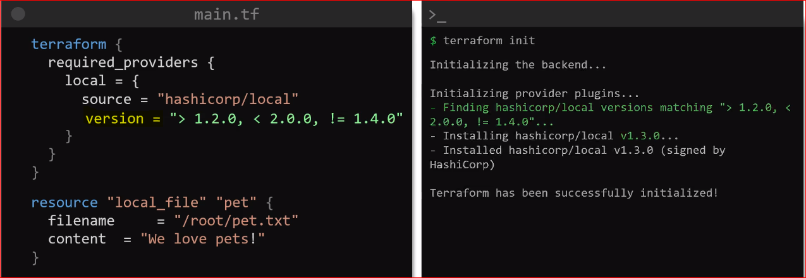

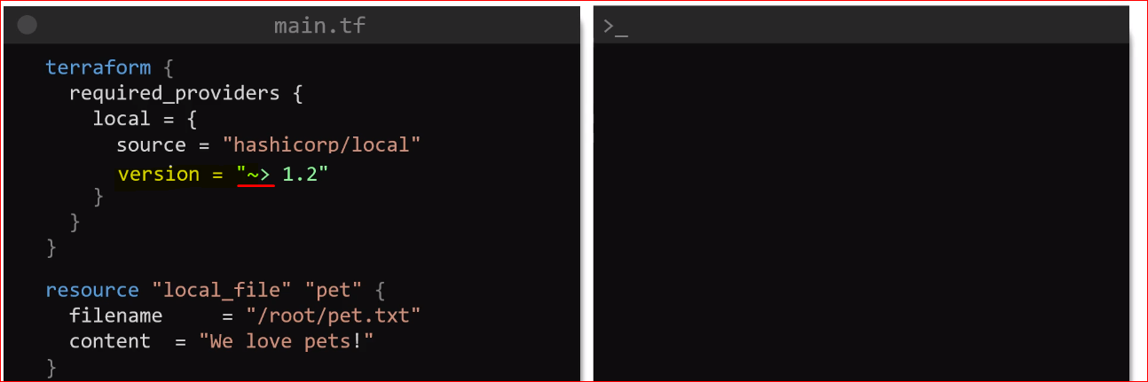

This means TF can download the version 1.2 or incremental version such as 1.3 , 1.4 , 1.5 all the way till 1.9

AWS

Introduction to IAM

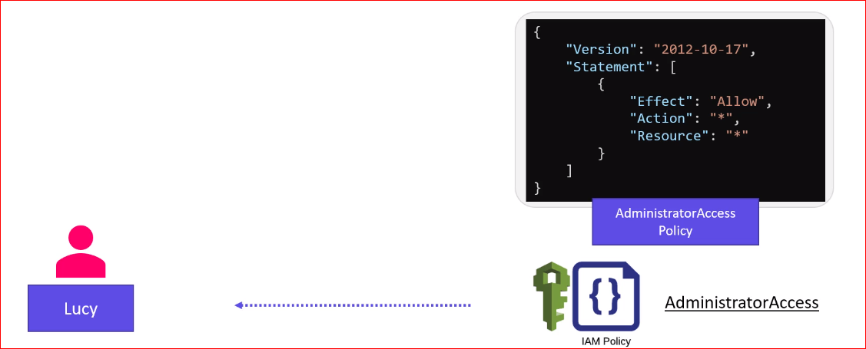

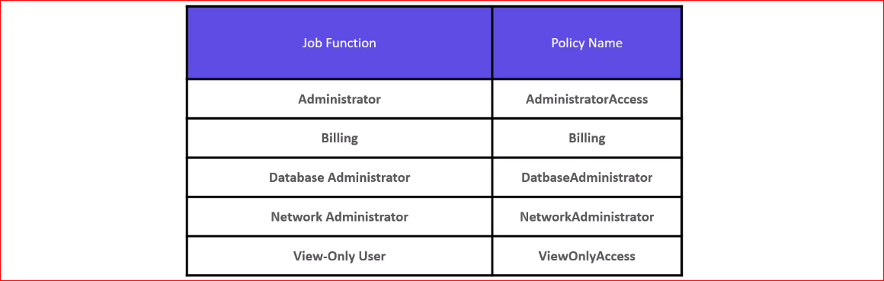

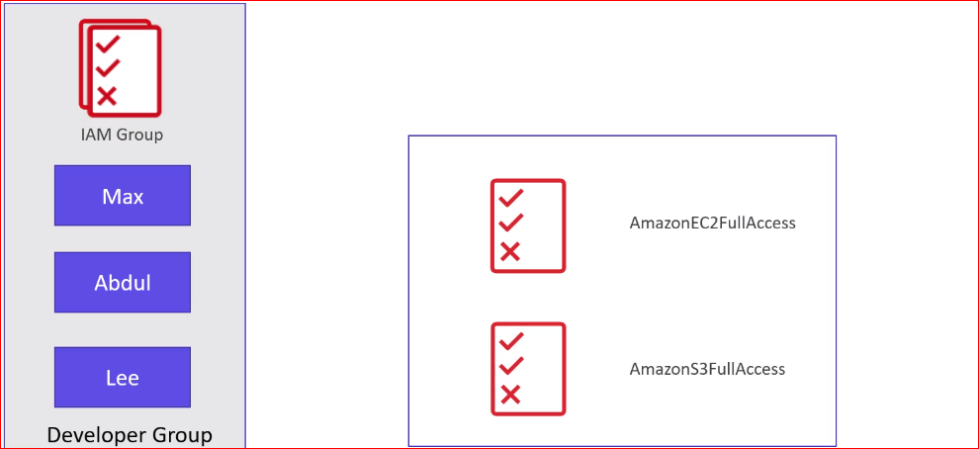

* Resources in AWS does have any permission to interact with other services by default
* They need to be granted access specifically
* Unlike other user, we cannot attach an IAM policy to the service directly
* Instead, in order to allow an EC2 instance to be able to interact to S3 buckets we have to create a Role
* An IAM role allows us to securely grants access to an AWS service to act on other AWS services in the account
* **IAM is independent on the region**

There are 2 ways to access AWS

* Using username and password to access from Console Management
* Using Access Key and Secrets to access programmatically

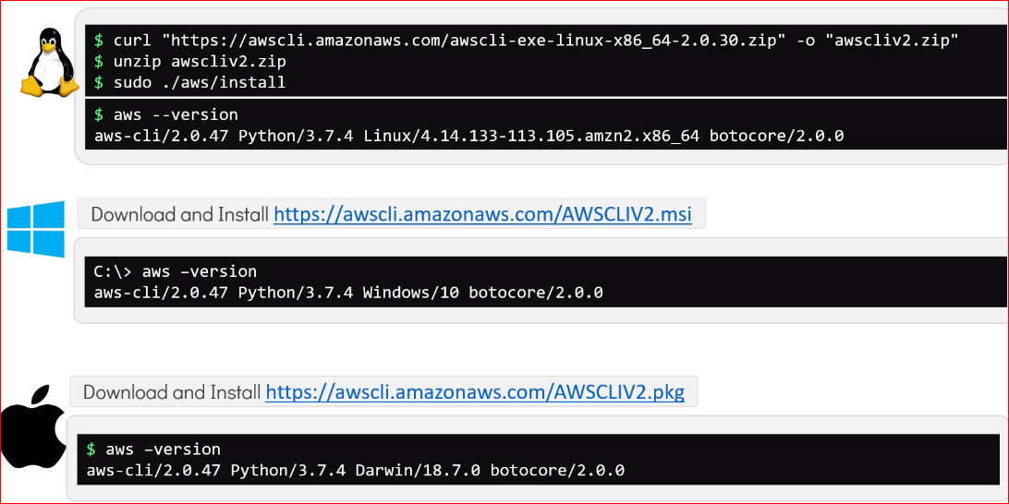

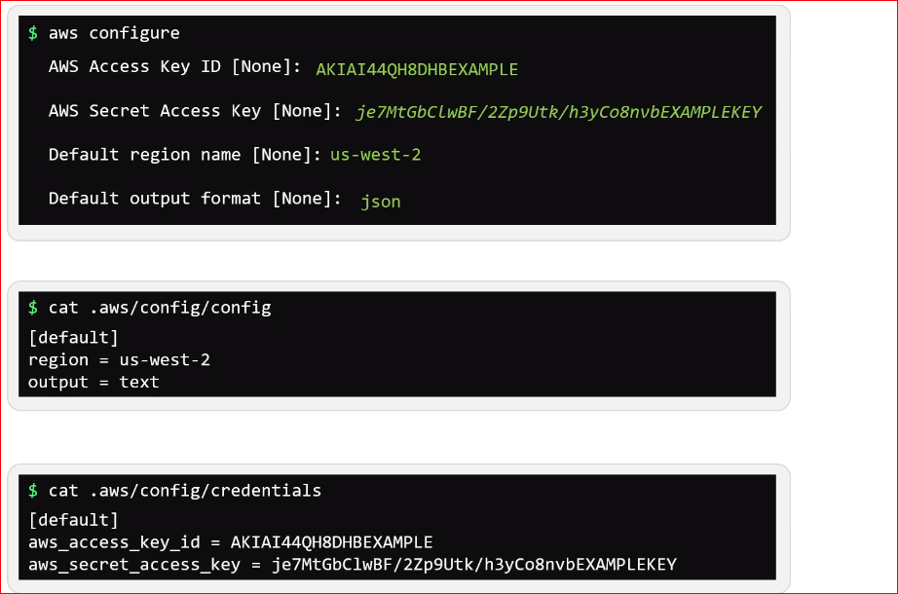

* Once AWS CLI is downloaded and install
* Use aws configure command to configure AWS by providing AWS access key and ID for programmatically access
* The output format can be json, yaml, text etc. default is json

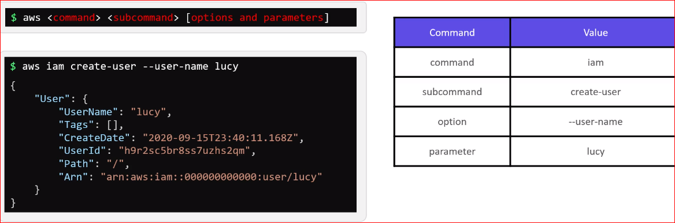

* ARN stands for Amazon Resource Name which is unique for every resource in amazon
* It is done to uniquely identify it with the AWS ecosystem

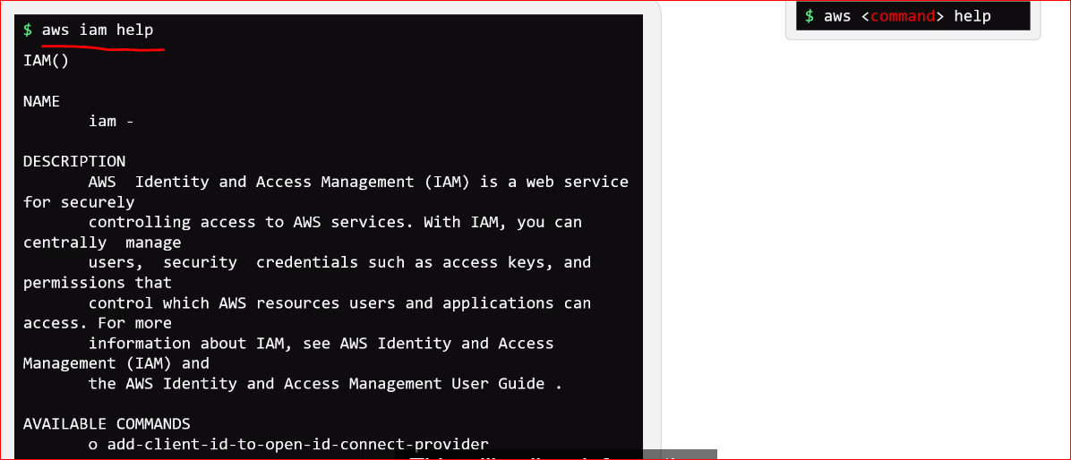

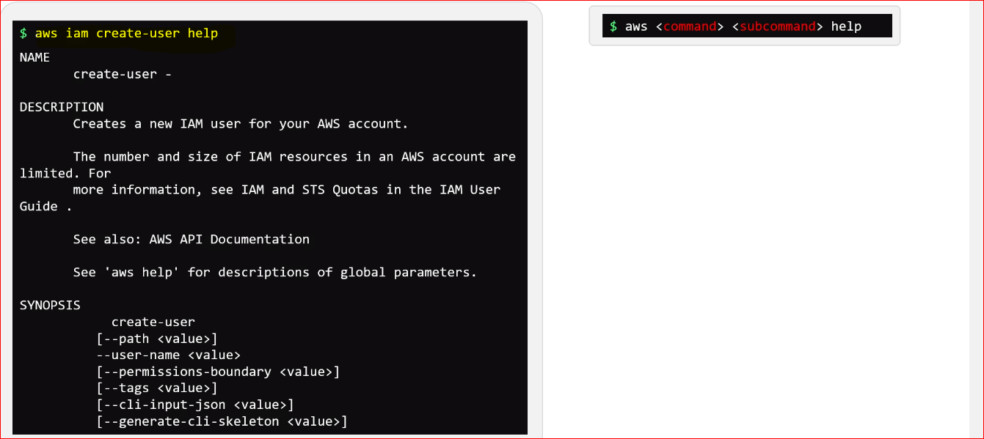

How to attach policy to **Mary** through CLI

aws --endpoint http://aws:4566 iam attach-user-policy --user-name mary --policy-arn arn:aws:iam::aws:policy/AdministratorAccess

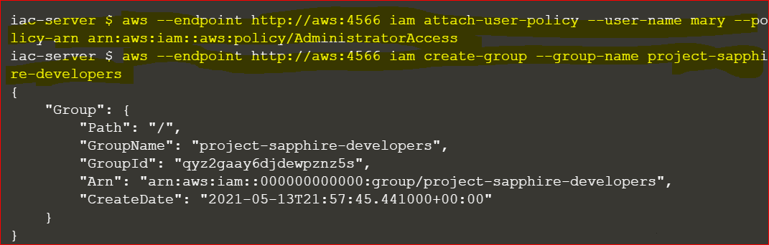

iac-server $ **aws --endpoint http://aws:4566 iam add-user-to-group --group-name project-sapphire-developers --user-name jack**

iac-server $ **aws --endpoint http://aws:4566 iam add-user-to-group --group-name project-sapphire-developers --user-name jill**

iac-server $ **aws --endpoint http://aws:4566 iam list-users**

{

"Users": [

{

"Path": "/",

"UserName": "jill",

"UserId": "s3a6vfgcw8olc3xts9vu",

"Arn": "arn:aws:iam::000000000000:user/jill",

"CreateDate": "2021-05-13T21:48:21.602000+00:00"

},

{

"Path": "/",

"UserName": "jack",

"UserId": "vkc5ccj40t8xqic4pgxf",

"Arn": "arn:aws:iam::000000000000:user/jack",

"CreateDate": "2021-05-13T21:48:22.235000+00:00"

},

{

"Path": "/",

"UserName": "marry",

"UserId": "5uqc1ye2fu7p4vithbbw",

"Arn": "arn:aws:iam::000000000000:user/marry",

"CreateDate": "2021-05-13T21:49:47.385000+00:00"

},

{

"Path": "/",

"UserName": "mary",

"UserId": "0fc1s113lfkos45w7b9g",

"Arn": "arn:aws:iam::000000000000:user/mary",

iac-server $ **aws --endpoint http://aws:4566 iam list-groups**

{

"Groups": [

{

"Path": "/",

"GroupName": "project-sapphire-developers",

"GroupId": "qyz2gaay6djdewpznz5s",

"Arn": "arn:aws:iam::000000000000:group/project-sapphire-developers"

}

]

}

What privileges are granted for jack and jill who are part of the group project-sapphire-developers?

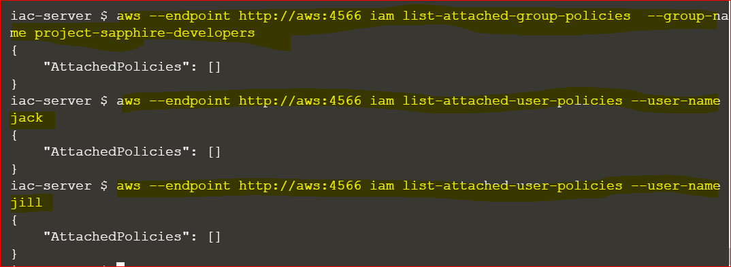

Both jack and jill need complete access to the EC2 service.

Attach the AmazonEC2FullAccess policy with the ARN: arn:aws:iam::aws:policy/AmazonEC2FullAccess to the group project-sapphire-developers.

**iac-server $** **aws --endpoint http://aws:4566 iam attach-group-policy --group-name project-sapphire-developers --policy-arn arn:aws:iam:aws:policy/AmazonEC2FullAccess**

**iac-server $** **aws --endpoint http://aws:4566 iam list-attached-group-policies --group-name project-sapphire-developers**

{

"AttachedPolicies": [

{

"PolicyName": "AmazonEC2FullAccess",

"PolicyArn": "arn:aws:iam::aws:policy/AmazonEC2FullAccess"

}

]

}

**IAM Resources using Terraform**

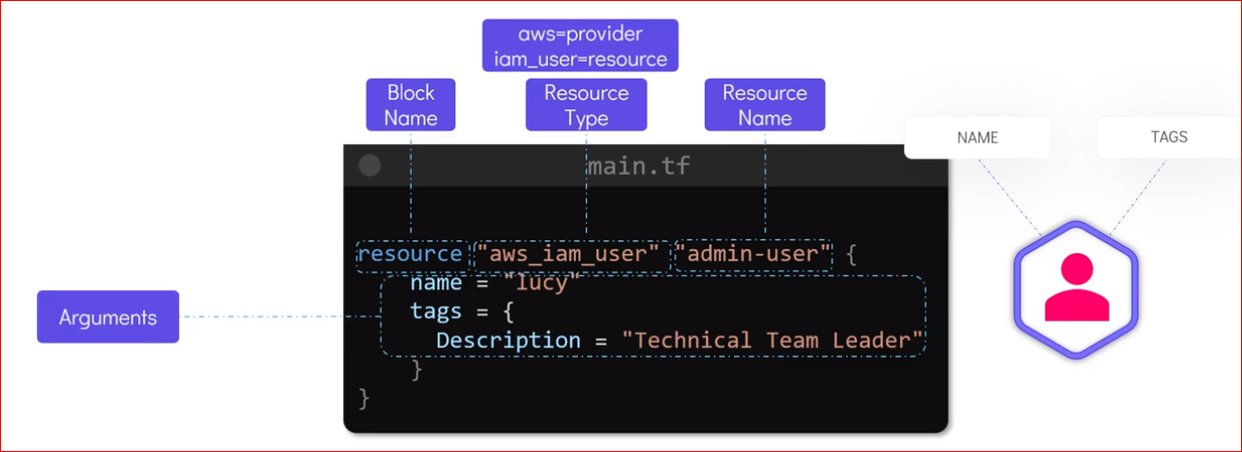

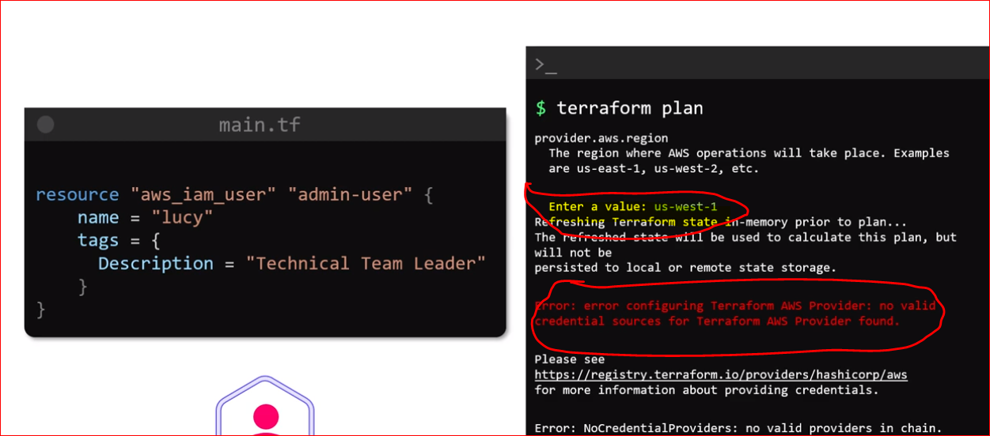

Even though IAM doesn’t depends on region TF by default needs region to proceed

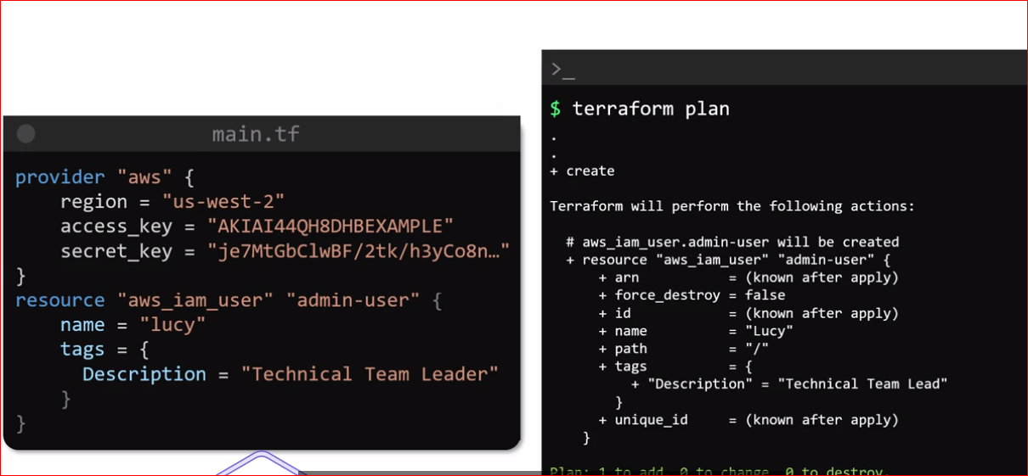

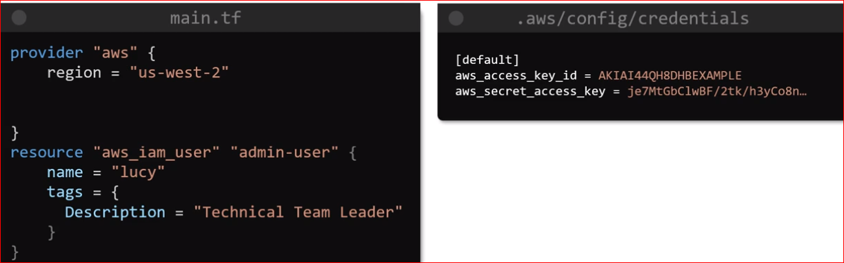

* Move the credentials from provider block into credentials file in AWS CLi by making use of AWS Configure command
* TF automatically use the credentials store in the credentials file
* Other way to use this value is by using environment variables export
* This will allow to remove the provider block completely

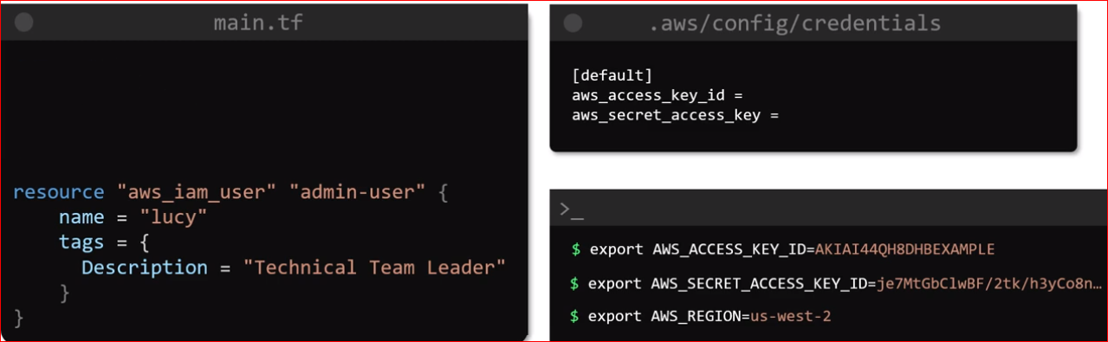

**IAM Policies with Terraform**

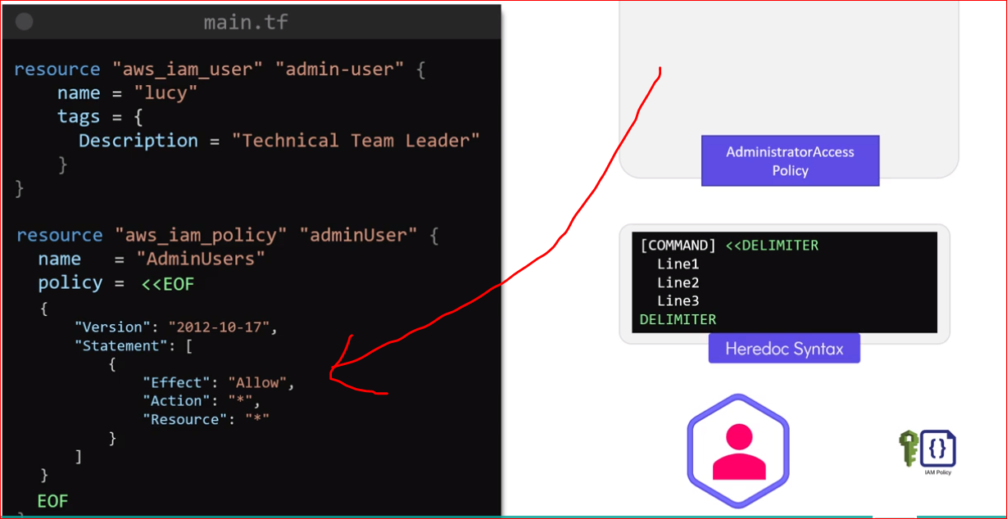

* Use heredoc syntax to add multiple line as shown above
* Now user and policy is created but policy is not assigned to any user as of now for that create a new resource as shown below

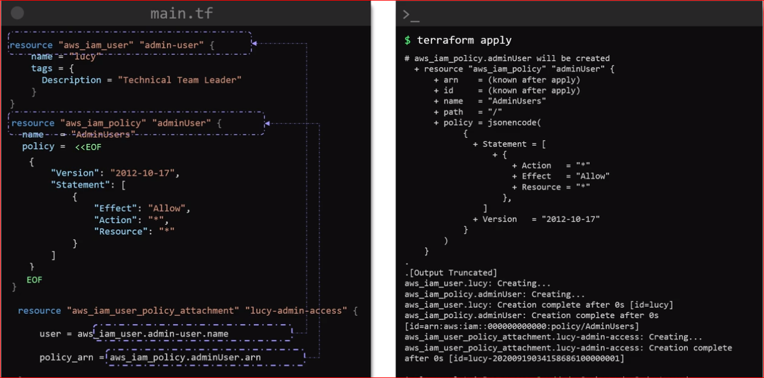

Another way:

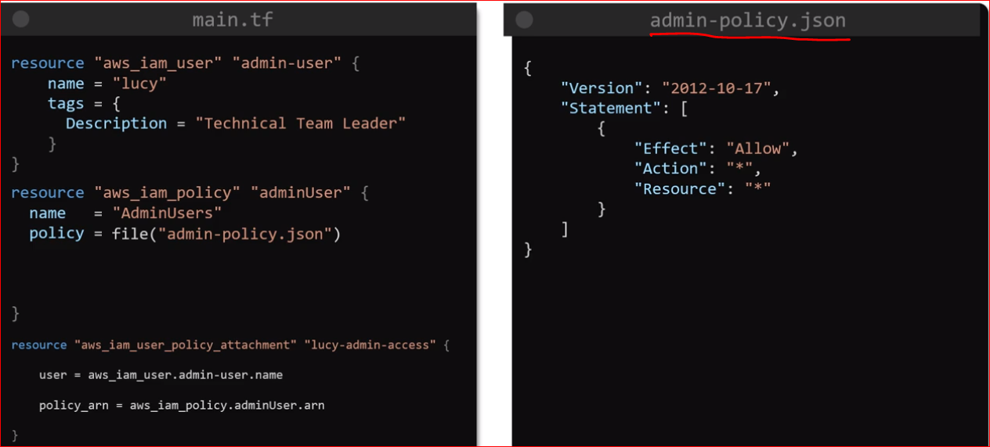

Labs:

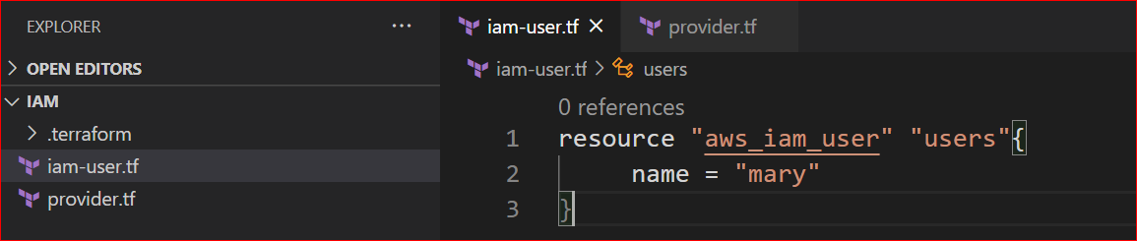

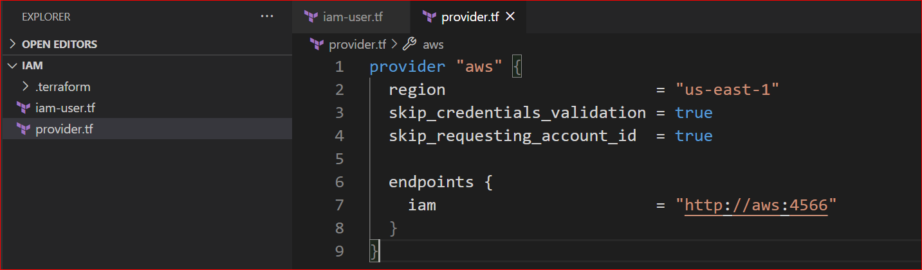

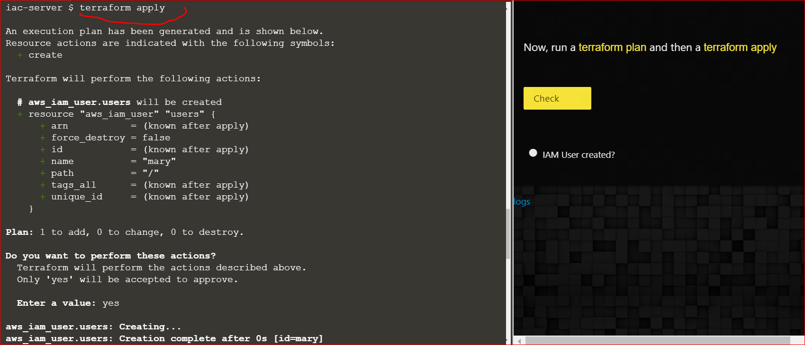

iac-server $ **cat terraform.tfstate**

{

"version": 4,

"terraform_version": "0.13.3",

"serial": 1,

"lineage": "c4bea443-1337-3be5-bdd9-77a73e64eb01",

"outputs": {},

"resources": [

{

"mode": "managed",

"type": "aws_iam_user",

"name": "users",

"provider": "provider[\"registry.terraform.io/hashicorp/aws\"]",

"instances": [

{

"schema_version": 0,

"attributes": {

"arn": "arn:aws:iam::000000000000:user/mary",

"force_destroy": false,

"id": "mary",

"name": "mary",

"path": "/",

"permissions_boundary": null,

"tags": null,

"tags_all": {},

"unique_id": "vmn7jeyh96ivpmd1z5y6"

},

"private": "bnVsbA=="

}

]

}

]}

**AWS S3:**

* Bucket name should be unique as aws create DNS for each bucket which is accessible from anywhere in the world
* No 2 buckets which are created on the different account can have the same name
* Name should be DNS complaint it means no upper or lower cases or underscore it should be between 3 to 63 characters long and it should not end with a dash
* Maximum size of the file uploaded is 5 terabytes

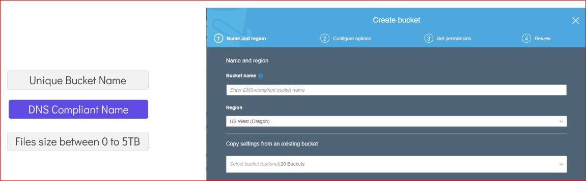

* Any object in S3 buckets consists of an object and metadata
* Metadata are the details about the object stored in the bucket

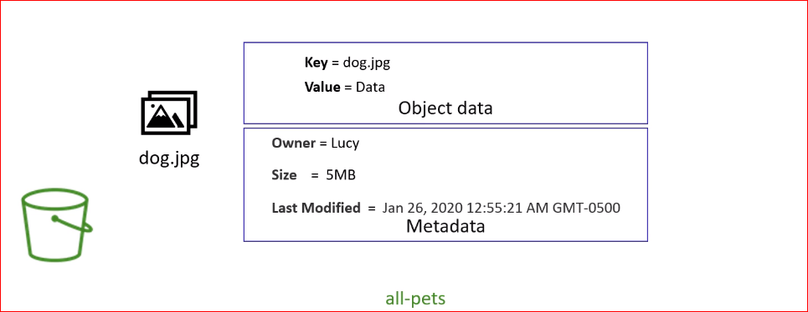

* Access to the bucket and its object are governed by bucket policies and access control list
* Bucket policies are the permission granted at the bucket level, access control list are more fine-grained access that can be used to define permission at an object level

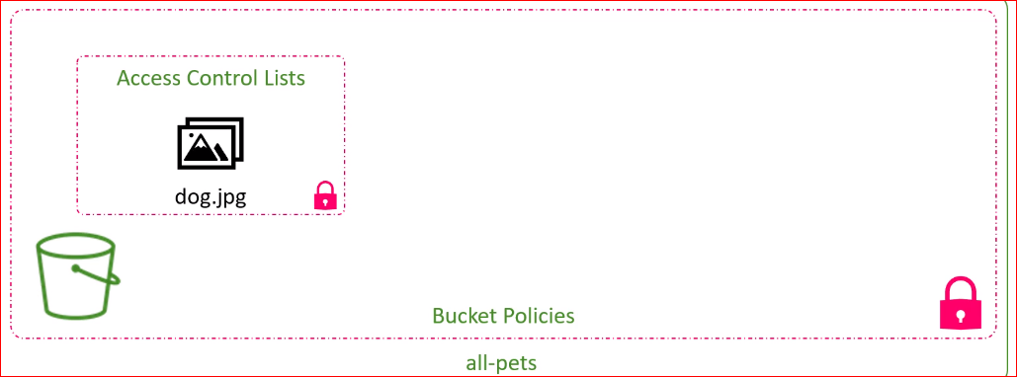

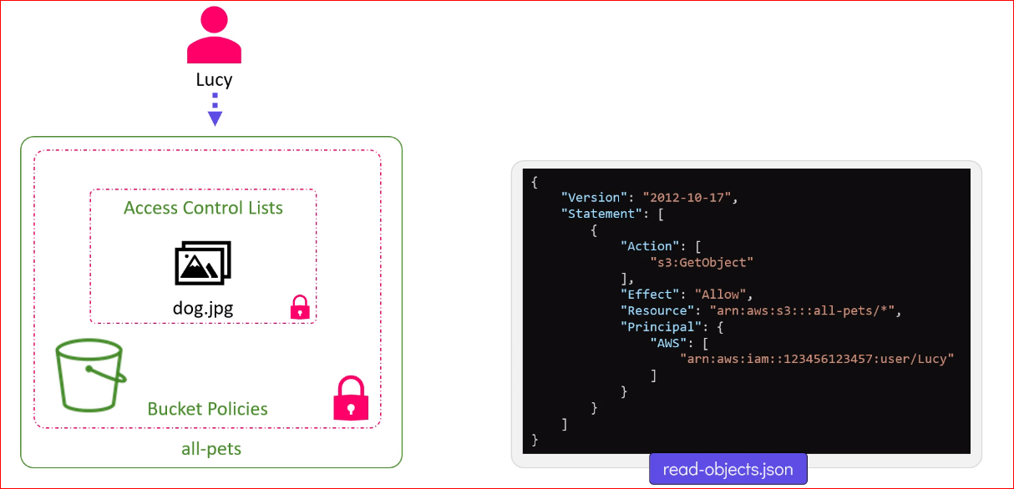

**S3 with Terraform:**

* If bucket name is not provided TF will create a bucket with unique name

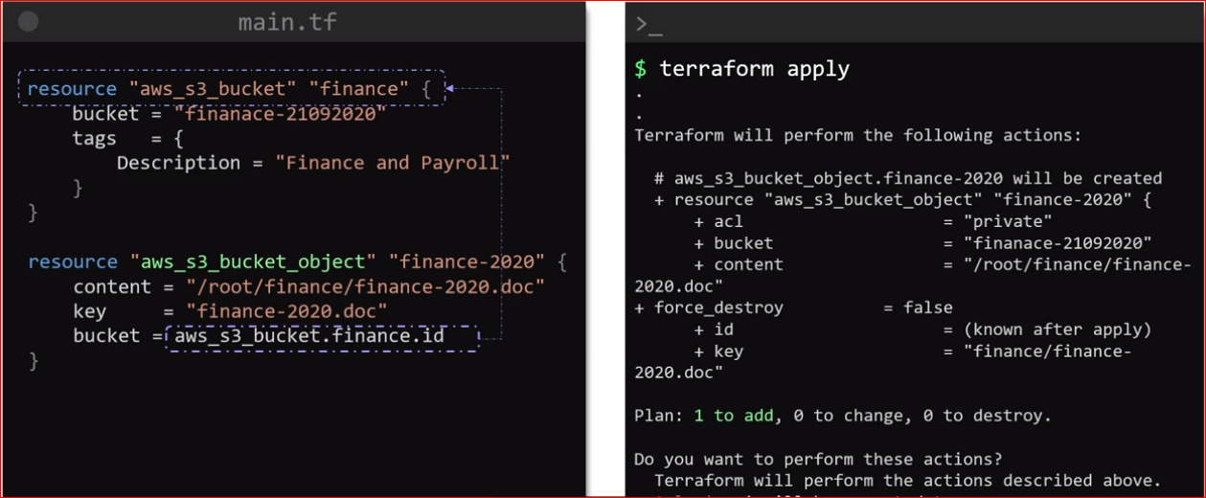

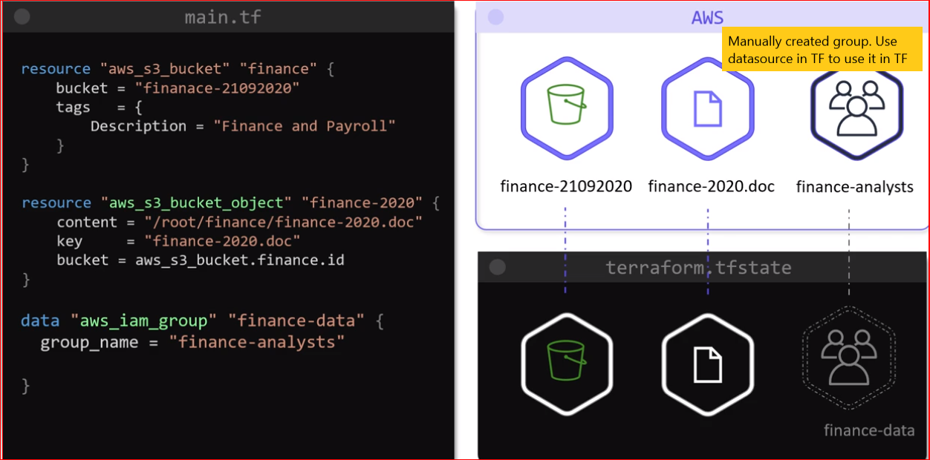

* Aws s3 bucket policy resource is used to attach a bucket policy to the bucket
* 2 compulsory arguments
  + Bucket name
  + Policy

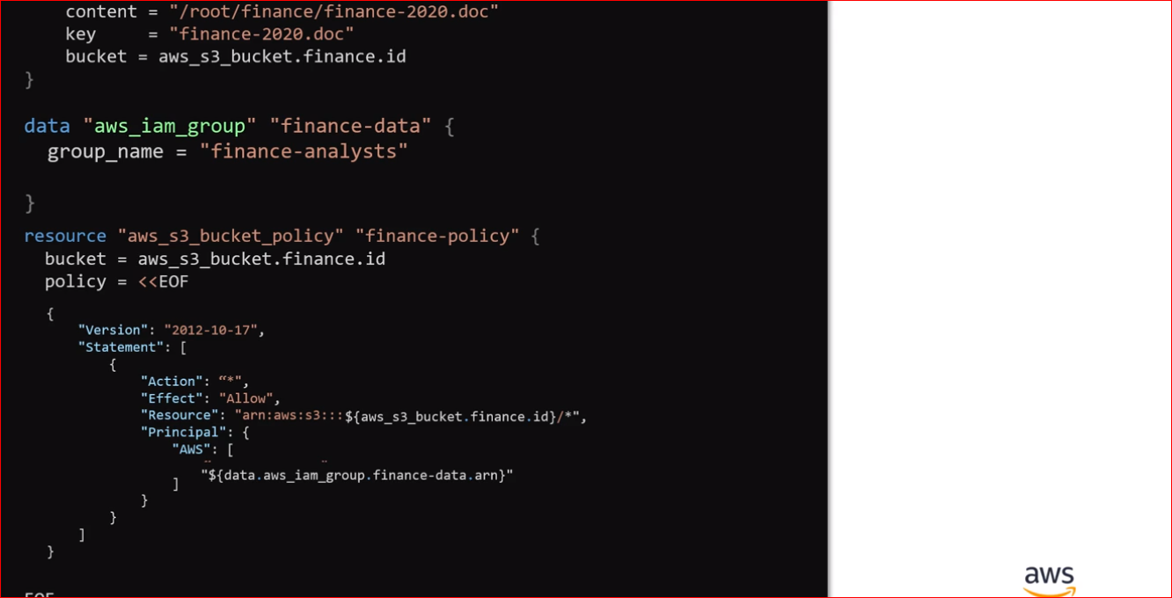

**Introduction to DynamoDB:**

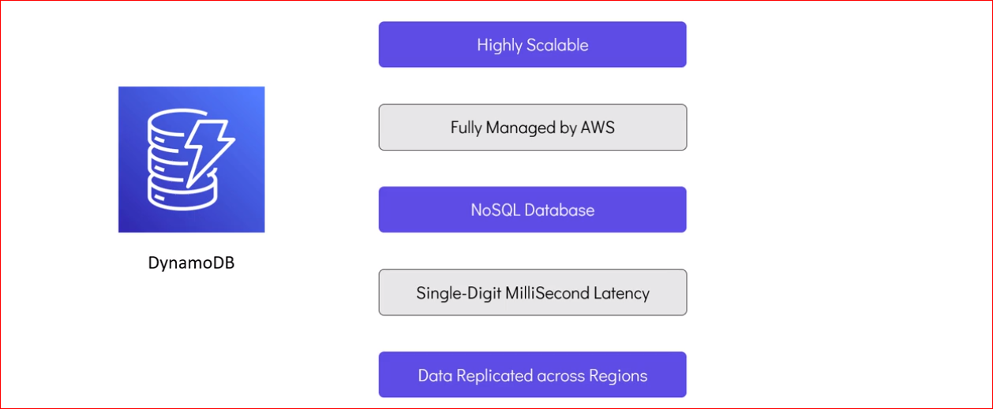

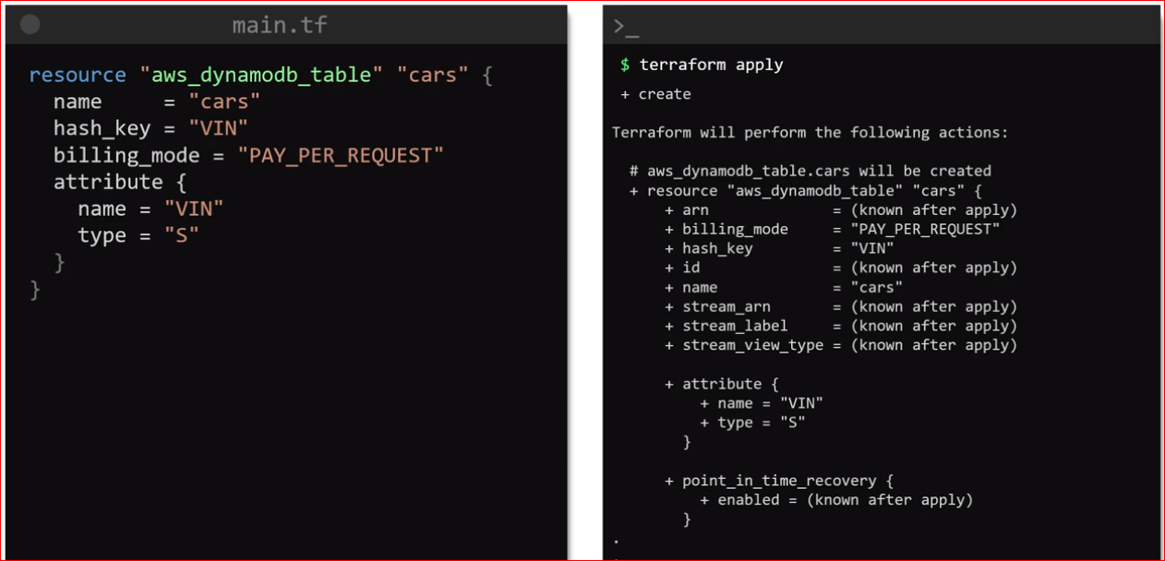

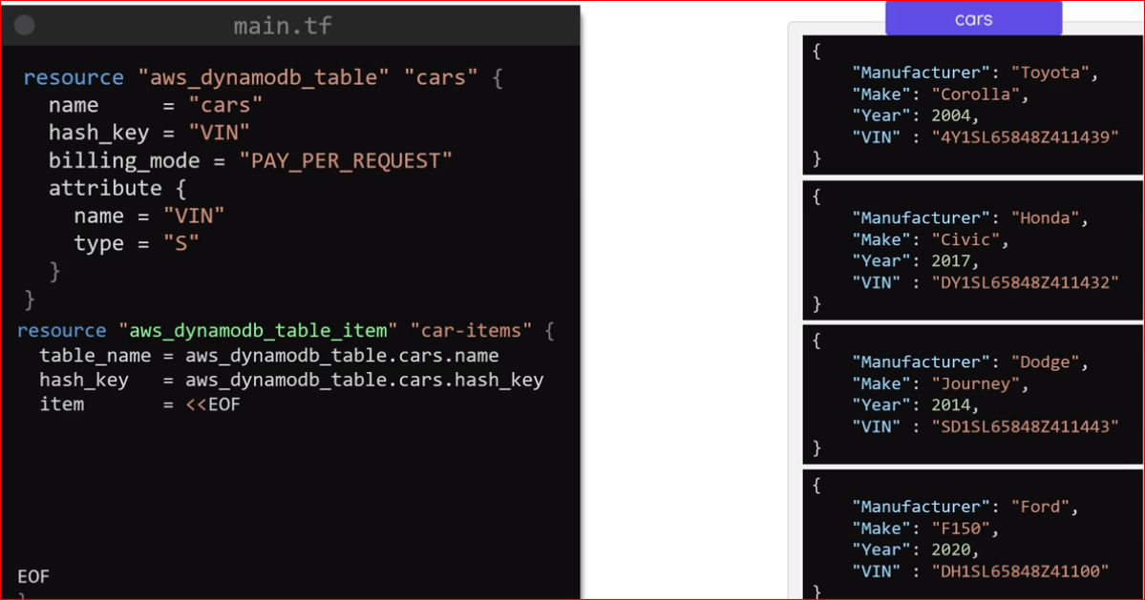

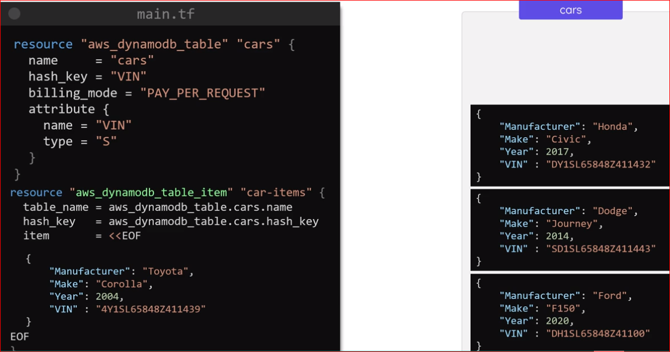

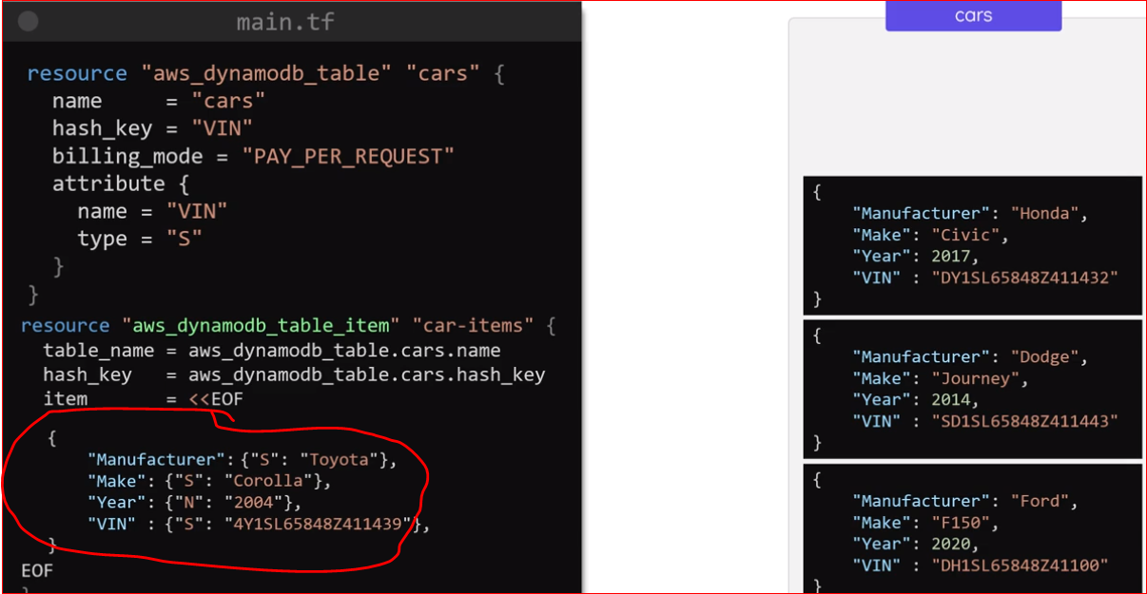

**Terraform Remote State**

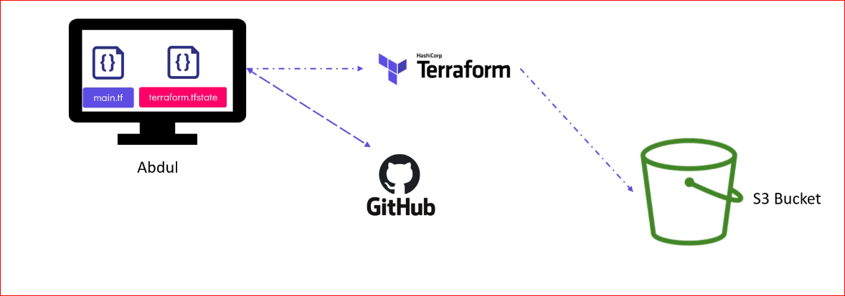

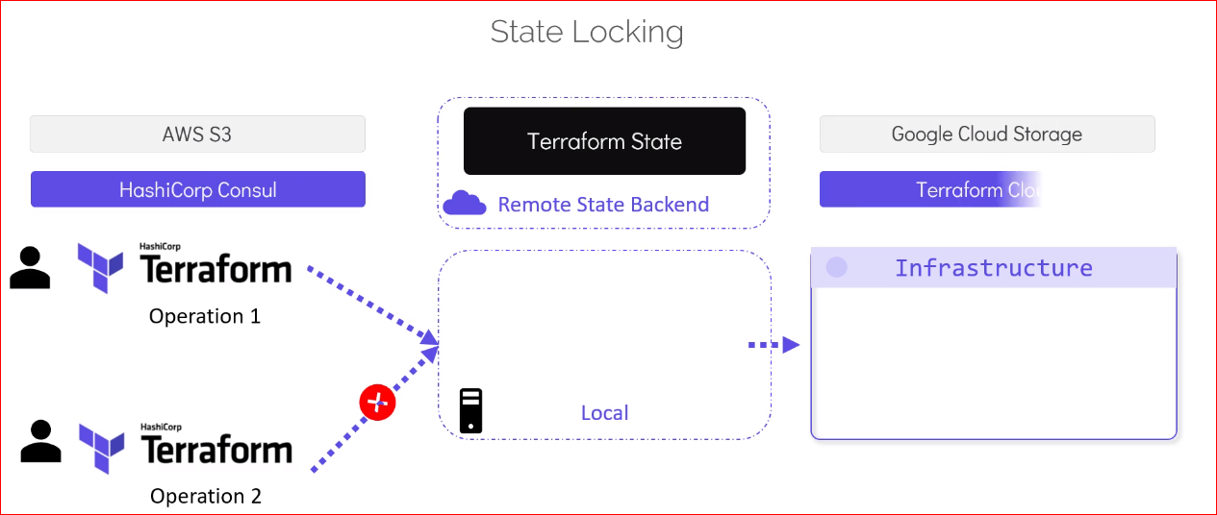

* The safest option is to user TF state backends with this option, the state files does not resides in the configuration directory or version control system and are moved to a shared storage system such as Amazon S3, HashiCorp Console, Google Cloud Storage and TF cloud
* When **a remote backup is configured**, TF will automatically load the state file from the shared storage everytime it is required by the TF Operations.
* It will also upload the updated TF state file after every apply
* Most importantly many of these remote backend options allow such as AWS S3 allow for state locking. This ensure that’s integrity of state file is maintained
* The remote backends provides different way to secure the storage such as encryption at rest and in transit to make sure that all the sensitive information inside it is secured

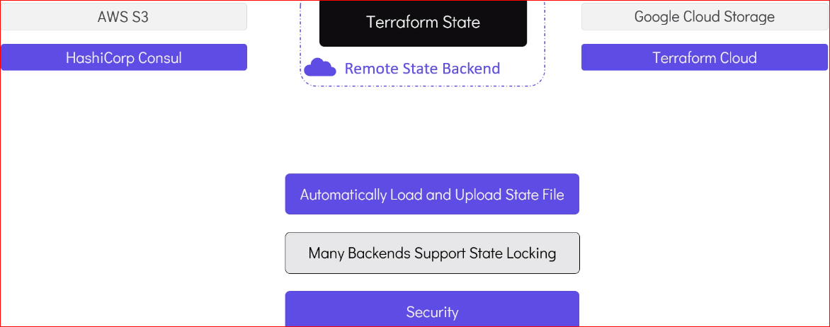

Remote backend with S3:

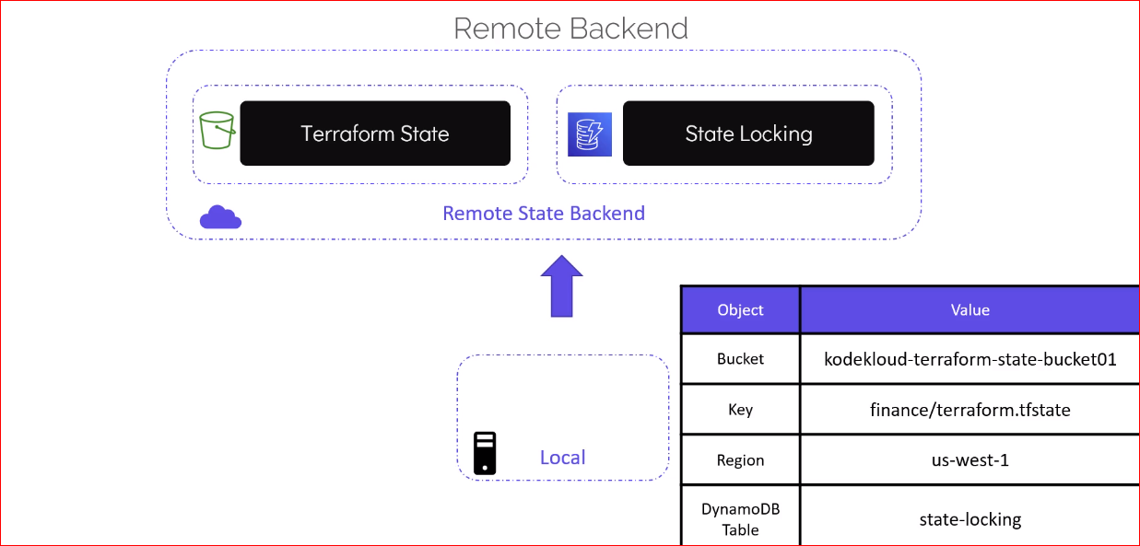

* We will see how to use S3 bucket and DynamoDB table to configure a remote backend
* We need 2 things
  + **S3 bucket:** To store TF state file
  + **DynamoDB table:** It will be used to implement state locking and consistency checks

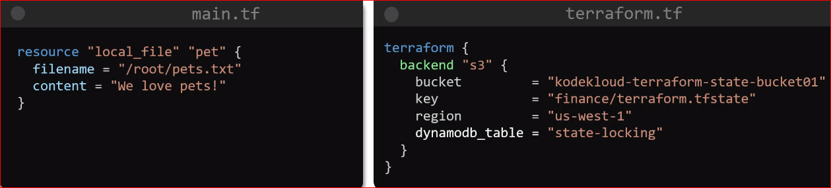

**Terraform state command**

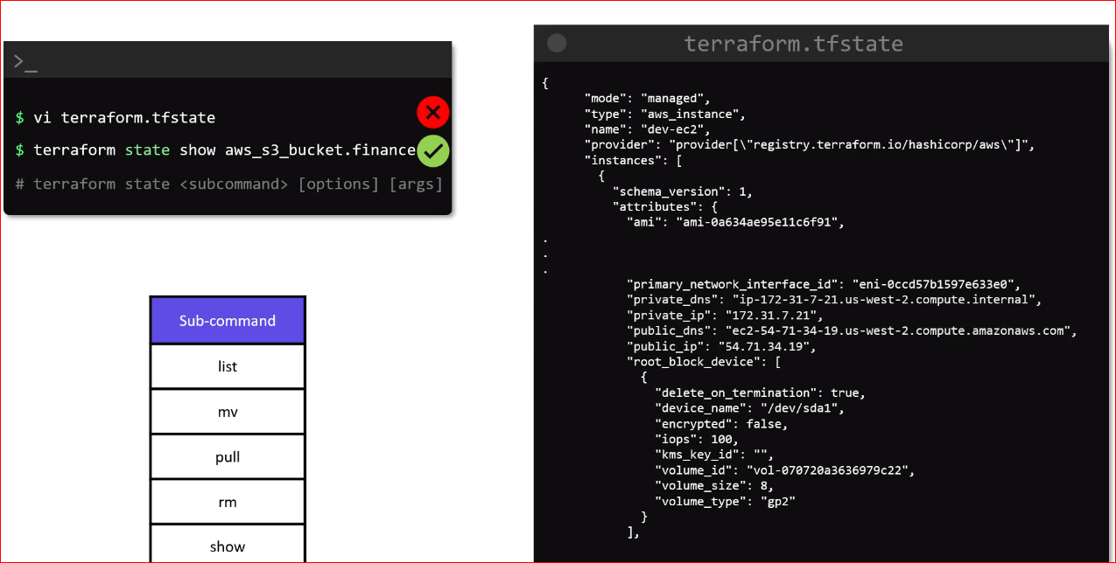

* **Terraform state list** : List all the resources recorded in the TF state file. It will only print the resource address and no other details about the resources
* **Terraform state show:** To get detailed of the resources from the state file. This cmd will show the attributes of a single resource in the state file that matches the given address
* **Terraform state mv [option] source destination:** This cmd is used to move items in the TF state file.

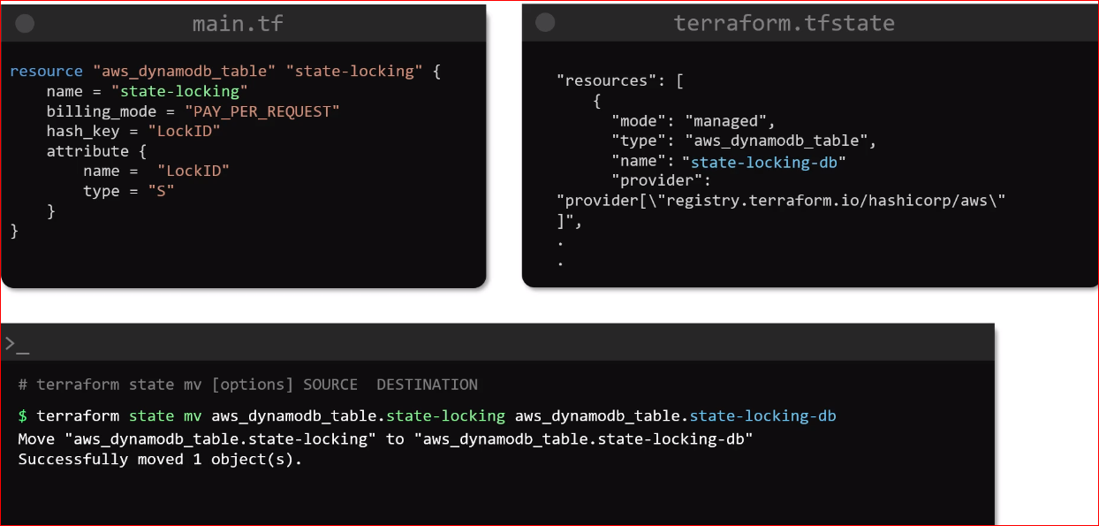

* **Terraform state pull [option] source destination:** It is used to view the content of the remote state file. With this cmd with can download and display the remote state on the screen

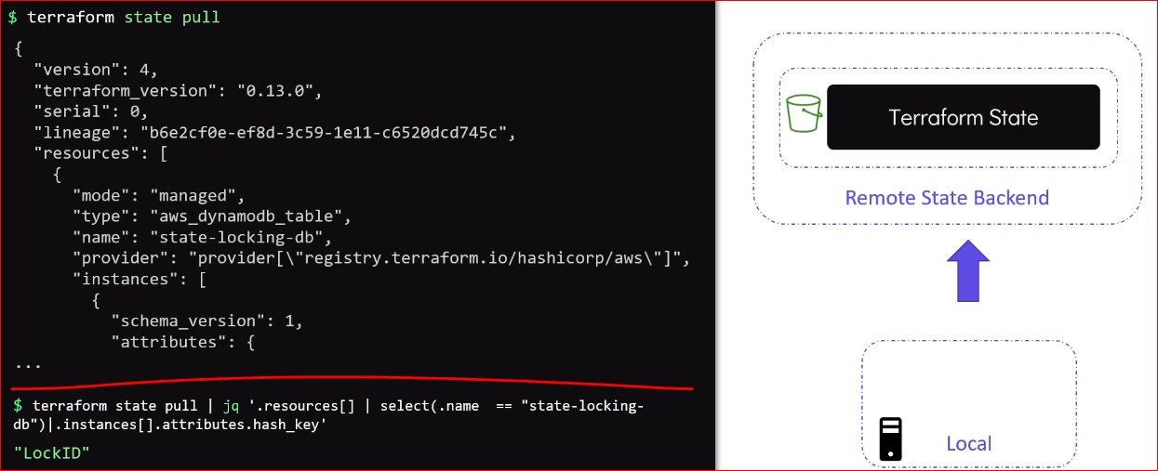

* **Terraform state rm ADDRESS:** It is used to delete items from the TF state file. The resource removed by TF state cmd are not actually removed from TF infrastructure. It is only removed from TF Management

**Terraform Provisioners:**

**AWS EC2:**

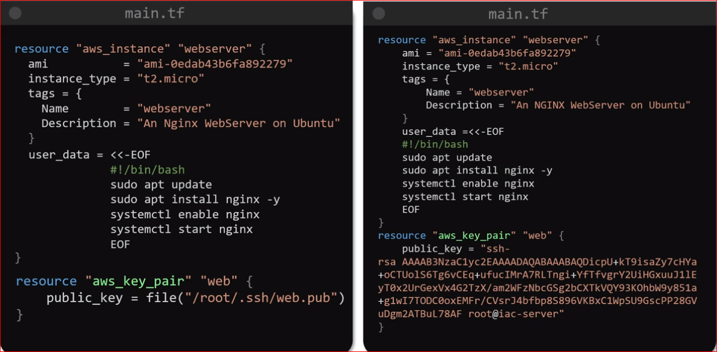

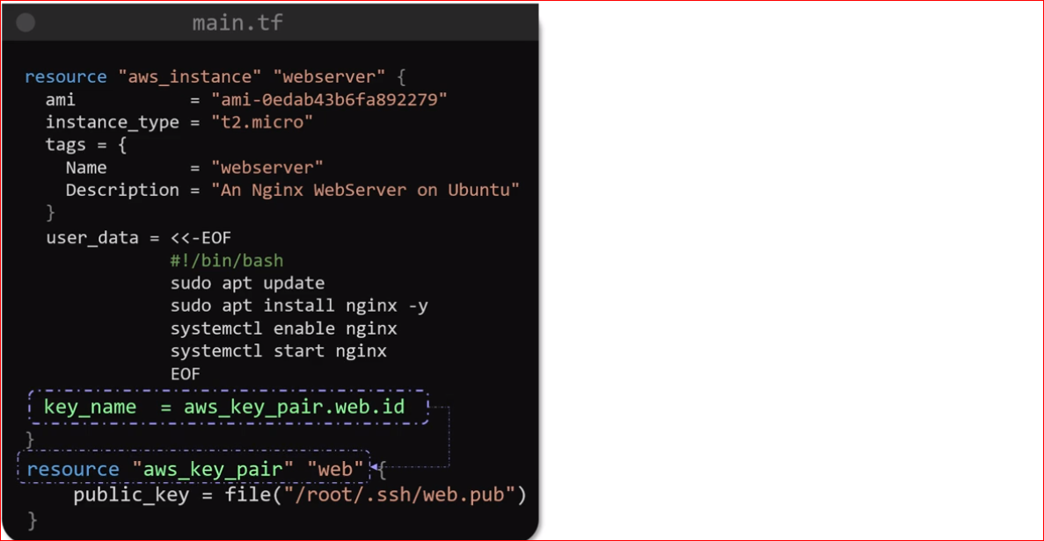

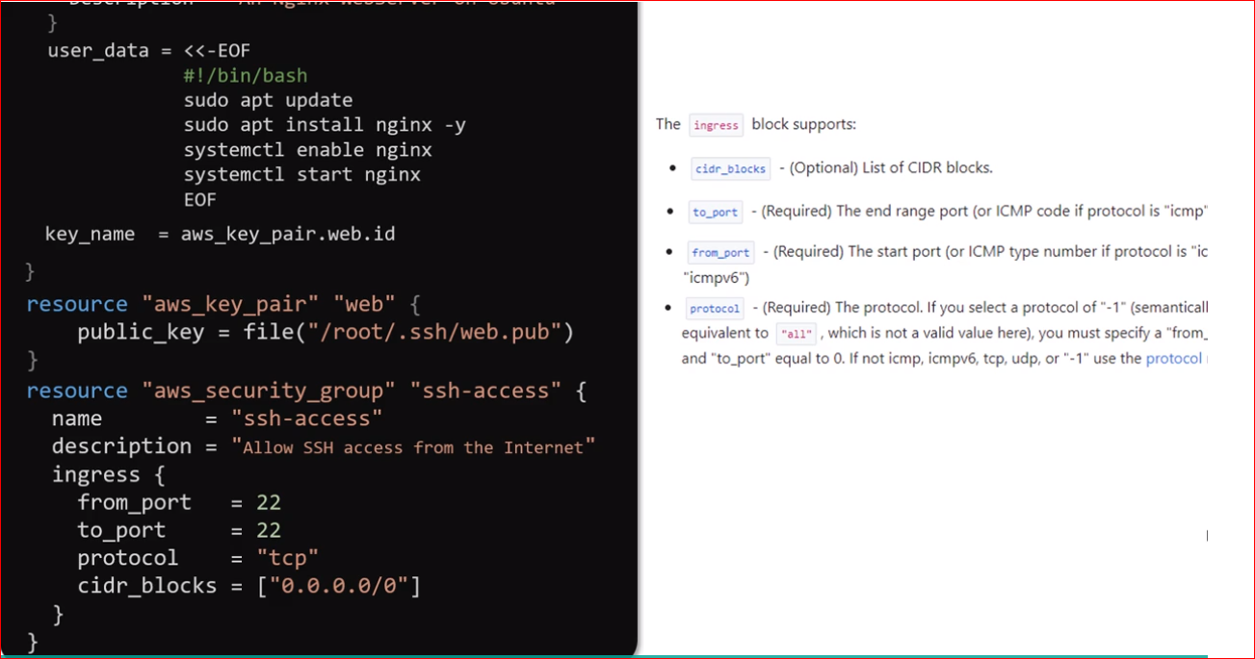

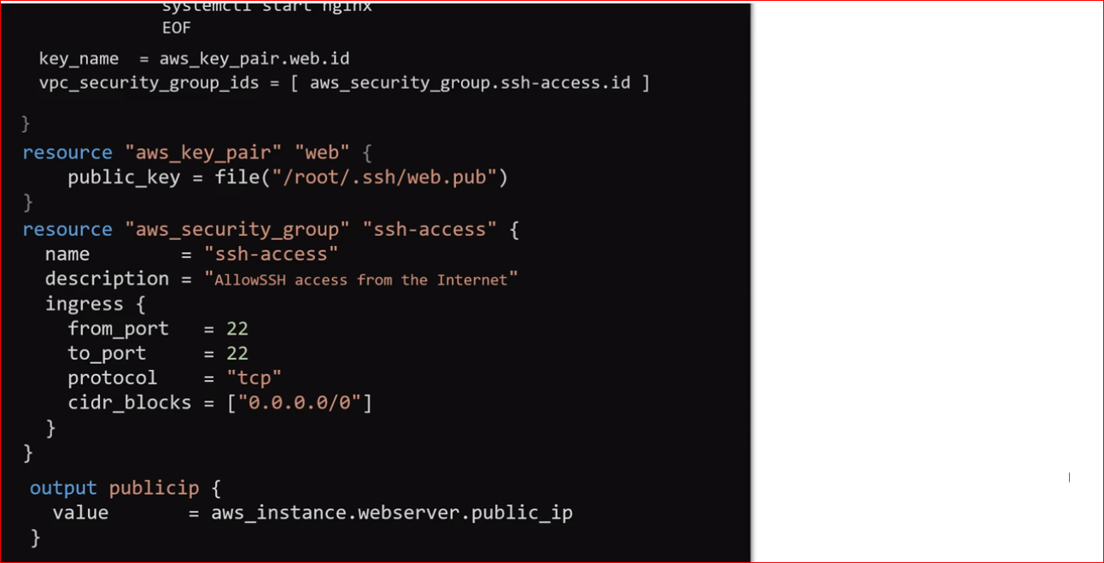

**Terraform Provisioner:**

* **Remote exec provisioner:** 
  + It is similar to user data feature that we used above. With this we can run same batch script on this machine in this case is EC2 instance.
  + The network connectivity between the local machine and remote instance should work
  + This can be done by seeing that SG are correctly setup to allow traffic to the instance
  + Secondly, a valid authentication method such as SSH choosing the key pair should also be setup for instance configuration

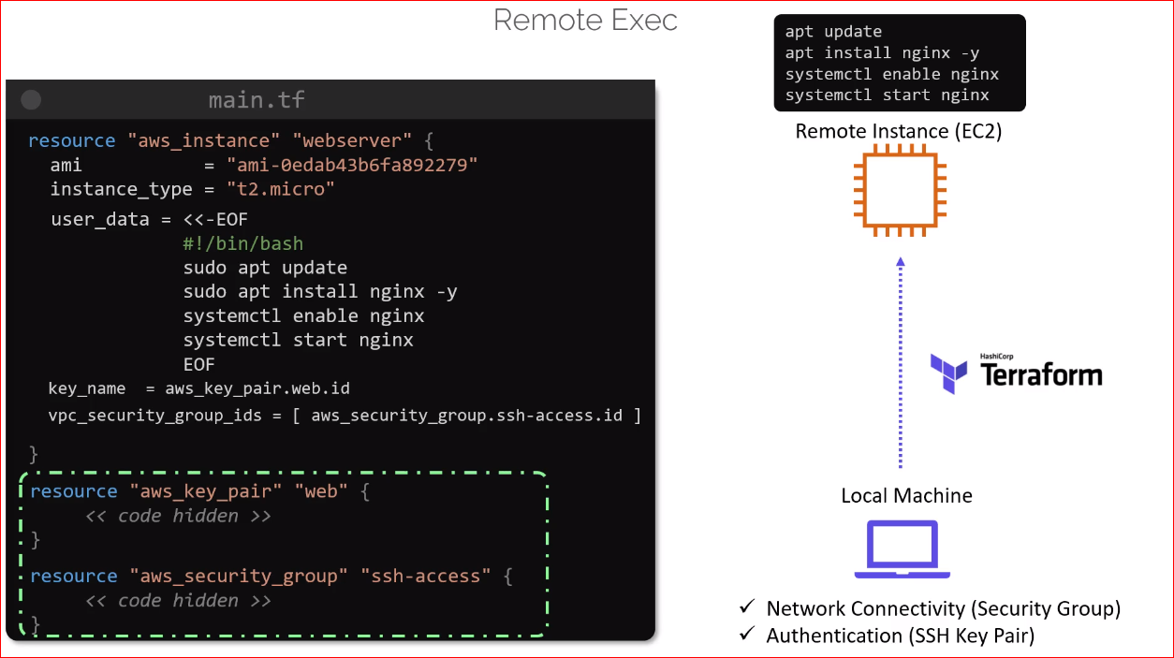

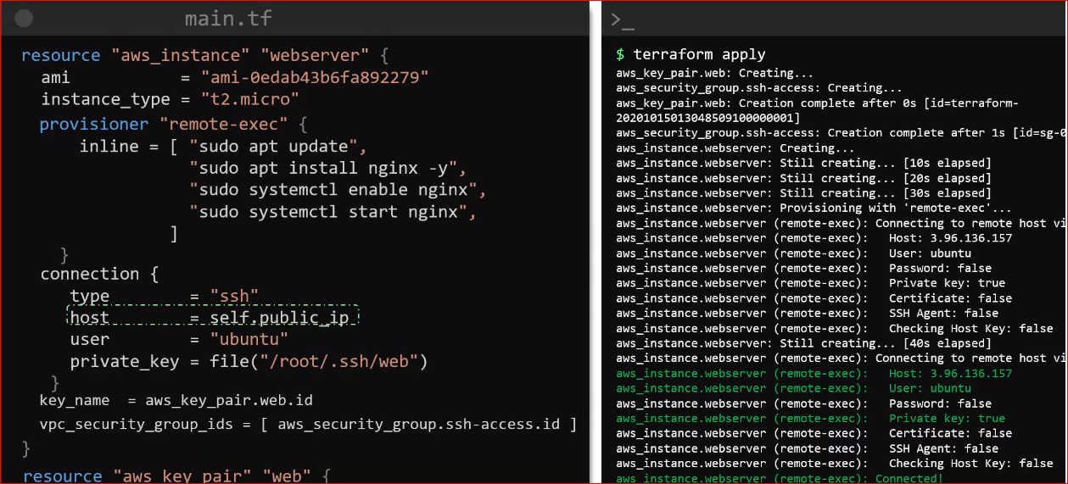

* **Local Exec Provisioner**
* Unlike remote exec, local exec provisioner is used to run task on the local machine were we are running the TF binary
* For example, if we want to store public ip address of the EC2 instance that we just provisioned in a IP.txt file in the /tmp file system
* We can run local exec provisioner

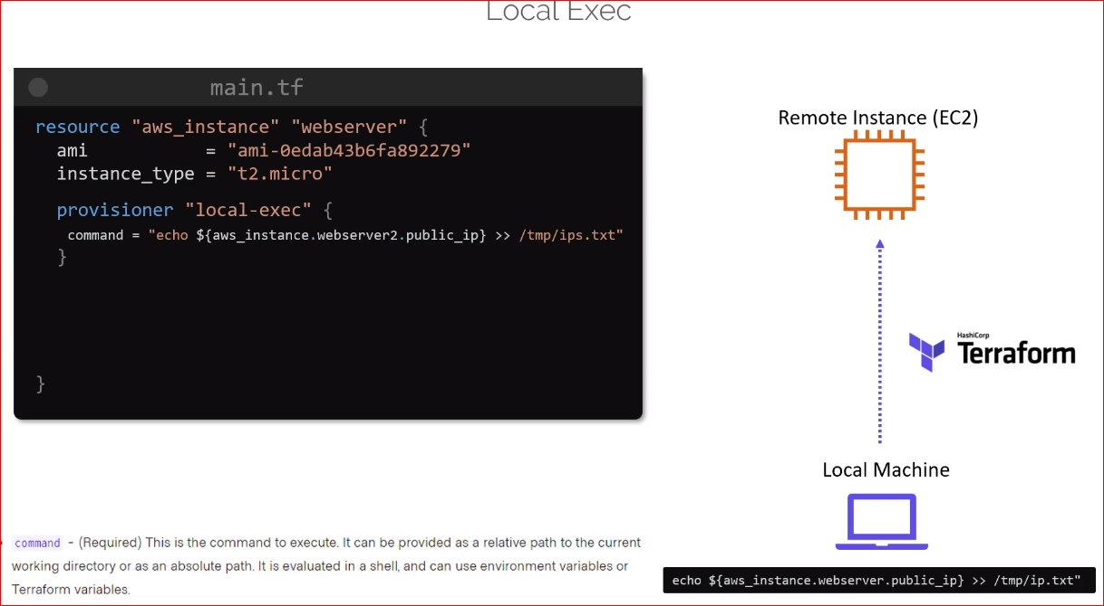

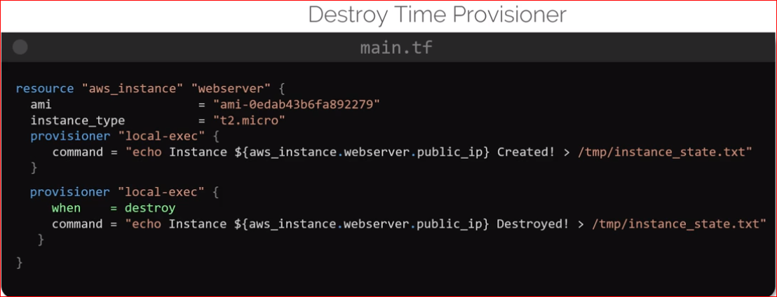

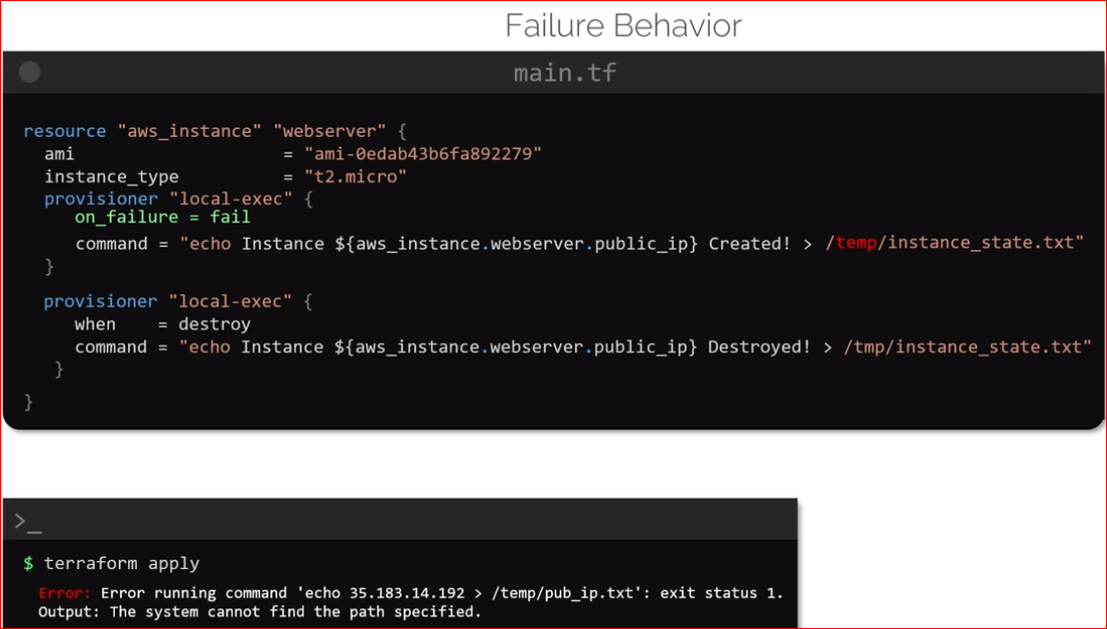

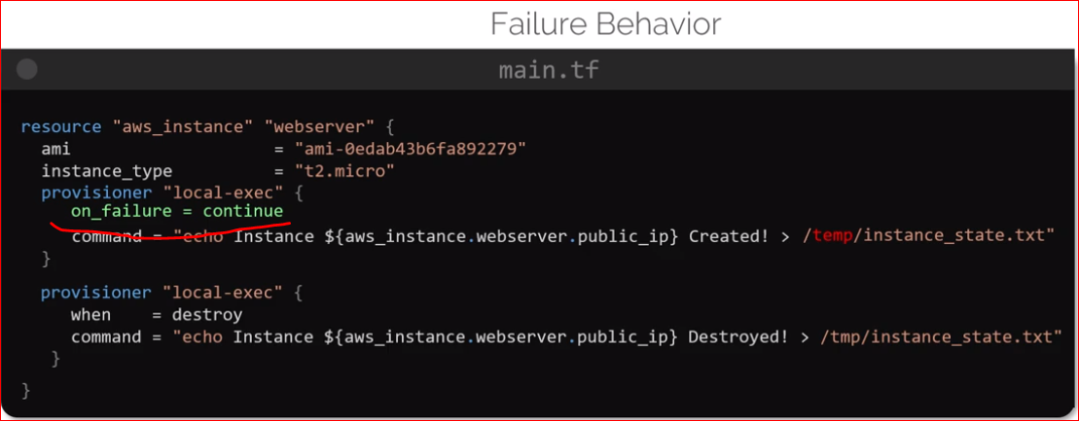

* If you don’t want apply to depend on provisioner failure and proceed without considering it use **on_failure = continue** as shown above